## PROJECT REPORT

### **ON**

# STRUCTURAL ANALYSIS OF AERO ENGINE CASING FOR DESIGN EVALUATION FROM DYNAMICS POINT OF VIEW

### **Submitted in partial fulfilment for award**

## CERTIFICATE OF PROJECT

### **TO**

## GAS TURBINE RESEARCH ESTABLISHMENT

## DRDO, BANGALORE

|  |  |
| --- | --- |
| **SUBMITTED BY:** ARSH GOYAL (11710459)  VINAYAK GOYAL (11710736)  ARBIND YADAV (11710627) | **UNDER THE GUIDANCE OF:** SHRI T.N SURESH (SCIENTIST ‘G’)  OWAIS MAJID SIR (SCIENTIST ‘D’)  RESHMA KHAN MAM (SCIENTIST ‘D’)  VINOD MITTAL (PROF. NIT KURUKSHETRA) |



## DEPARTMENT OF MECHANICAL ENGINEERING

## NATIONAL INSTITUTE OF TECHNOLOGY KURUKSHETRA

## 2017-2021

TABLE OF CONTENTS

S.NO. TOPIC PAGE NO.

Table of contents 2-3

Evaluation summary report 4

Abstract 5

1 Introduction to gas turbines 5-6

2 Working of gas turbines (Brayton cycle) 6-7

3 Addition of different components in Brayton cycle to increase efficiency 7-9

4 Types of gas turbine engines on the basis of thrust augmentation 9-13

5 Components of gas turbine engines 13-16

6 Stress strain analysis 16-17

7 Determination of stress on planes using Mohr circle 17-18

8 Determination of stress using Strain gauge 18-21

9 Positioning of strain gauge 21-22

10 Theories of failure 22-24

11 Fatigue analysis 24-27

11.1) Factors causing fatigue

11.2) Design criteria for fatigue

12 Basics of vibration 27-28

13 Vibrations in 1dof system 28-31

13.1) Free vibration

13.2) Damped vibration

13.3) Forced vibration

13.3.1) Magnification factor

14 Vibration in 2 dof system 31-34

15 Vibration in multi degree of freedom system (modal analysis) 34-38

15.1) Methods to convert continuous system in multi dof system

15.2) Application of modal analysis

16 casing 38-44

16.1) how vibration is produced in casing

16.2) Rotor dynamics

16.2.1) Effect of various parameters on critical speed

17 Theory of Finite Element Method 44-46

17.1) General description of FEM

17.2) Steps to do Finite Element Analysis

18 Meshing 46-49

18.1) Types of elements

18.2) Selection of elements

18.3) Elements size

18.4) Element shapes

18.5) Requirement in geometry before meshing

18.6) Quality checks for meshing

19 Modal analysis of casing 49-53

19.1) preprocessing of model

19.1.1) Geometry formation

19.1.2) Meshing of model

19.1.3) Material properties

19.1.4) Application of boundary conditions

19.1.5) Type of analysis

19.2) Processing and Post-processing

20 References 54

## EVALUATION SUMMARY REPORT

This **REPORT** describes the internship project we have had with GAS TURBINE RESEACH ESTABLISHMENT, DRDO Bangalore dated from **January** **16,2020** to **May** **29,2020**.

During this period, we learnt about the following:

1**.Theoritical:**

* Basics of gas turbine theory
* Types of gas turbine engines
* Brayton cycle
* Thermodynamics of Brayton cycle
* Gas turbine engine

1. Axial compressors

2. Turbines

3. Combustion chamber

3. Nozzle

4. After burner

* Determination of stresses and strains using strain gauge
* Theories of failure
* Fatigue
* Basics of vibration
* 2 dof vibrations
* Modal analysis
* Rotor dynamics
* Finite element method
* Meshing

**2.Software tools:**

* Hypermesh (for modelling and meshing)
* Ansys (for pre-processing and analysis)

We want to express our heartful gratitude to the scientists, mentors and lab members for enlightening us with these details and helping us understand each process very minutely.

Arsh Goyal

Vinayak Goyal

Arbind Yadav

## STRUCTURAL ANALYSIS OF AERO ENGINE CASING FOR DESIGN EVALUATION FROM DYNAMIC POINT OF VIEW

**Abstract:** In most of the mechanical applications vibrations of one or many components of a machine is a considerable drawback. In real life applications 90% of total failures are due vibrations of components of a machine. Failures due to vibrations are fatigue type of failures which can happen at stresses less than that of yielding stress of a material. Which makes it difficult to control.

There are methods to control vibrations like damping but these methods involve increasing weight which in turn causes further problems so all these factors concerning vibrations leaves us with no other choice but to have a design to start with. So, considering vibrations in design parameters is compulsory.

This article concentrates on understanding basics of gas turbines, measurement of stress and strain, fatigue stresses, basics of vibration, analysis and validation of dynamic vibrations on the aero engine casing (modal analysis), and also our basic learnings of meshing and analytic tools (hypermesh & Ansys) are also given.

**1) Gas turbines**: A gas turbine is an internal combustion engine in which gas is used as a working fluid which is burnt inside a combustion chamber and is used to turn a turbine by the pressurized gas.

The gas turbine operates on the principle of Brayton Cycle, in which air is compressed with the help of compressors and then this compressed air is burnt with fuel in the combustion chamber under constant pressure condition and the resultant gas is allowed to expand on the turbine to produce work.

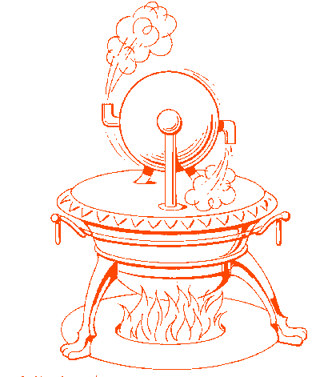The idea of gas turbine comes from gas rotating the engine when given proper direction. This is the basic idea behind producing a rotary motion from the engine. In gas turbine engines we use rotary and stator blades to produce this rotating motion

Let’s look into how the idea of gas turbine came up: -

In 1629, Giovanni Branco developed a device that uses jet steam to rotate the turbine, which is used to operate machinery.

* In 1678, Ferdinand Herbiest made use of steam jet as power and built a model carriage.
* In 1791, John Barber was granted the first patent for the turbine engine, which has many elements the same as of the modern gas turbine. It was used as a reciprocating compressor. Fig no. 1. Steam rotor
* In 1903, The General Electric company started its gas turbine division. Stanford, who is an engineer leads most of the projects. He developed General Electric turbosupercharger during world war 1, which is a great outstanding development. This General Electric turbosupercharger uses hot gases from the reciprocating engine to drive the turbine wheel, which in turn drove a centrifugal compressor used for supercharging.
* In 1914, Charles Curtis invented the Curtis steam engine and got his patent granted in 1914 in the U.S. for a gas turbine engine.
* In 1928, Sir Frank Whittle proposed the use of a gas turbine engine for propulsion. In 1930, He patented a design for a jet aircraft engine.
* In 1941, Sir Frank Whittle design-based turbojet engine flown in Great Britain.

1.1) Now let's see **why gas turbine is preferred over a reciprocating engine** in some cases:

* Gas turbines are continuous power machines. But reciprocating engines are discrete power machines they give power only one time in 4 strokes. So large amount of power can be produced by turbine engine.
* Size of gas turbine engines are very less as compared to same power reciprocating engines.
* Efficiency of gas turbine engine are more than reciprocating engines.
* Gas turbine engine have very less emissions.

1.2) Why we **don’t use gas turbine engines in cars**: -

* In gas turbine engines there is continuous supply of heat. Due to material is in high thermal stresses and it can even melt. Due to which we need to use exotic material like titanium and nickel alloys. Cost of vehicle increases if used in cars. That’s why we use reciprocating engines in cars.
* Gas turbines engines high efficiencies only if used in large units
* Gas turbines provide constant power (for high efficiencies) buts in road vehicles we need variable power

**2)** **Working of gas turbine (Brayton cycle): -**

Gas Turbine basically follows a thermodynamic cycle which is known as Brayton Cycle. As we know that in Carnot cycle the efficiency can be maximized by increasing temerature difference between the input and output working fluid. Similarly, in Brayton cycle if the pressure difference across the turbine is increasing then the maximum efficiency can be achieved. There are three main components of a gas turbine: Compressor; Combustion Chamber; Turbine. Firstly, air (working fluid) is compressed (increases the pressure of air) in the compressor which is a adiabatic compression process which means neither heat is added not heat is released.

After that the compressed or the pressurized air enters the combustion chamber where it is mixed with fuel and burnt and all this process takes under the constant pressure condition, so this process is constant pressure heat addition. Now, the resultant hot gas coming out of the combustion chamber expands through the turbine to perform work, so this process is known as

adiabatic expansion.

Most of the power produced in the turbine is used to run the compressor and remaining power is used for the other useful work which can be like producing thrust in case of turbojet engine, or can be a power turbine which is connected to fan or generator.

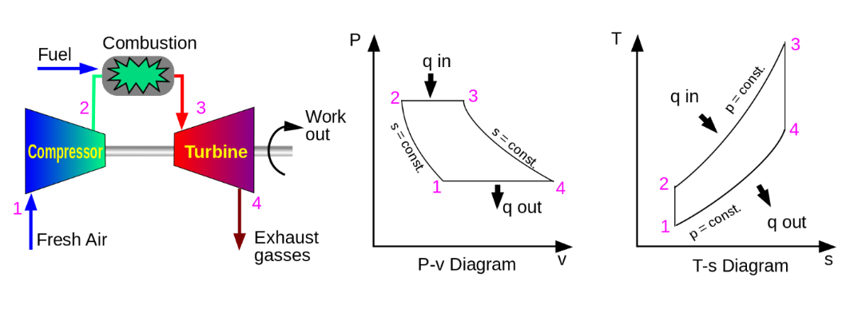As after expansion on the turbine, the gas is not again reused in the same system so this system is known as an open system gas turbine.

 Fig no. 2. Brayton cycle

In terms of pressure ratio and temp. ratio of compressor. This is for the ideal Brayton cycle.

Now there are other arrangements of Brayton cycle present. In all the cases for making p-v diagrams we will consider that the gas at exit is going to the inlet of engine

**3) Addition of different component for efficiency improvement:**

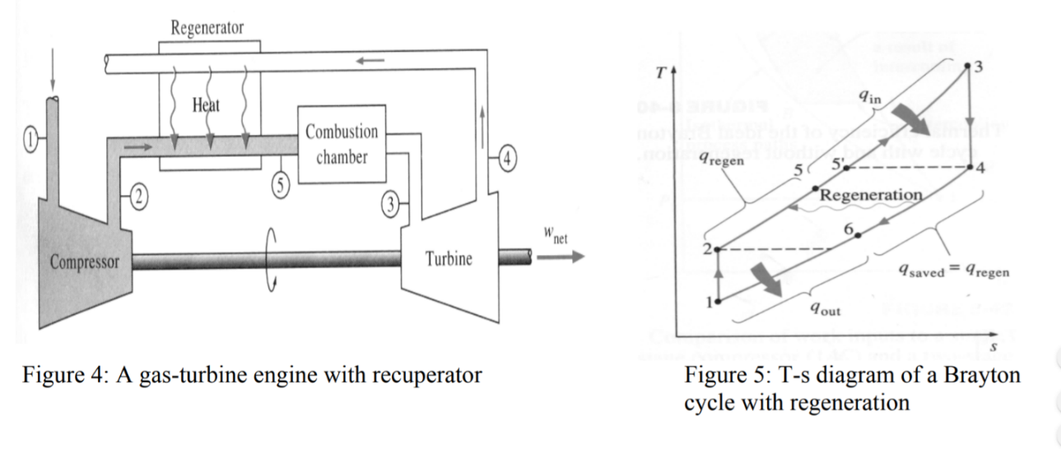**3.1).** **Gas turbine with a regenerator**: - One different component that can be added to the gas turbine is Regenerator (Heat Exchanger).

Fig no. 3 Brayton cycle with regenrator

It is placed between the compressor and the combustion chamber. Through the heat exchanger the compressed air form compressor is to combustion chamber and also the exhaust gas is passing through heat exchanger to the atmosphere. Heat exchanger recapture some of the exhaust gas energy and preheat the air entering the combustion chamber and the hot gas from combustion chamber is expand on turbine. This is basically done on low pressure turbines. Heat exchanger is added so as to increase the efficiency. This can improve efficiency more than 5%.

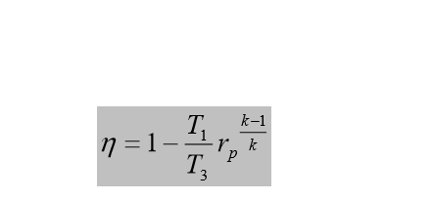Thermal efficiency of Brayton cycle with regeneration.

Now if we compare it with efficiency of simple Brayton cycle then we come to know that it depends on pressure ratio and max to min temperature. So, its efficiency depends on max to min temperature.

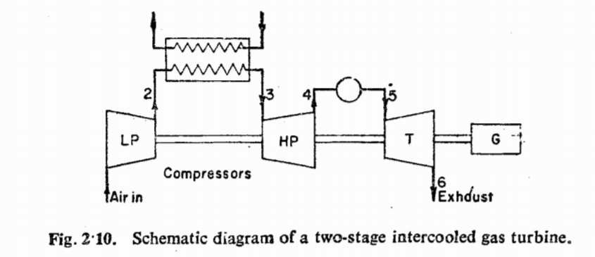**3.2). Gas turbine with intercooler**: - In Intercooling we use a heat exchanger to cool the gases in compression process. When the compressor involves two stages of compression then we can use the intercooler between them to cool down the flow. This cooling process decreases the work input required for compression in high stage compression unit. The cooling fluid can be anything like water, air. In marine gas turbine engines, the sea water is used to cool the fluid. It is observed that a successful implementation of the intercooler can improve the gas turbine output.

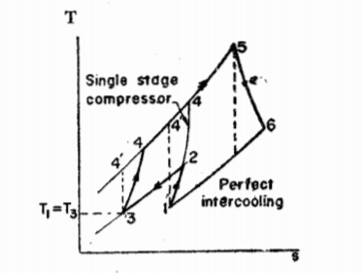

Fig no. 4. Brayton cycle with intercooler

**3.3).** **Gas turbine with reheater: -**

Reheating is applied in a gas turbine in such a way that it increases the turbine work without increasing the compressor work or melting the turbine materials. When a gas turbine plant has a high pressure and low-pressure turbine a reheater can be applied successfully. Reheating can improve the efficiency up to 3 %. A reheater is generally is a combustor which reheat the flow between the high- and low-pressure turbines.

In jet engines an afterburner is used to reheat. It is attached at the exhaust of the turbine. As a result, the thrust is increased. But it takes a lot of fuel to increase the thrust.it is also known as afterburner.

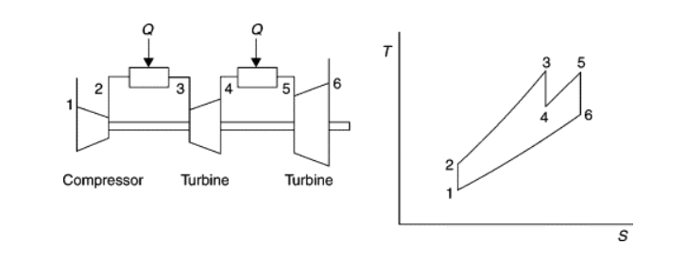 Fig no. 5. Brayton cycle with reheater

* We make use of combination of all so that we can get better efficiency like Brayton cycle with heat exchanger, regenerator and reheater all three in one cycle.

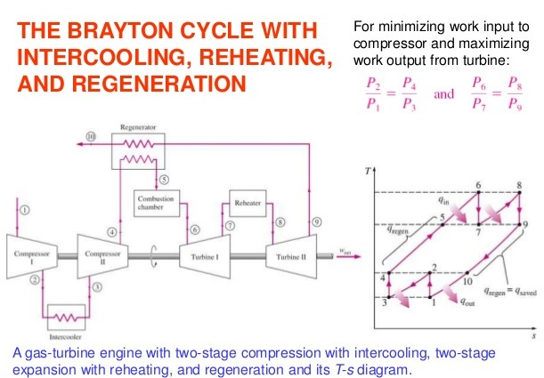

**3.4). Brayton cycle with intercooler, reheater and regeneration**: - In this we use all the three additions in our cycle. For this purpose, we need two compressor stages and two turbine stages. The thermal efficiency and work output get increased very much. So, all these modifications are used in practical applications. With the help of intercooler, we decrease the work input and with the help of reheater work output is increases. so, it is very useful in practice.

Fig no. 6**.**

**4) Types of gas turbines engines:** gas turbine engines are very useful in propelling the jets. The path the air takes through the engine and how power is produced determines the type of engine. Four types of air breathing gas turbine engines are used to propel and power aircraft. They are the Turbojet, Turboprop, Turbofan, turboshaft. There is other type of engines are also there but mainly these four are used

**4**.**1) Turbojet engine**: -

This is simplest of all designs. turbojet engine consists of 4 compartments. First the compressor in this air is compressed and sent to the combustion at a high speed and pressure. in combustion chamber fuel is injected and combustion process occurs. This expanding air drives the turbine, which is mutually connected to the compressor with the help of shaft. work input required for the compressor must be compensated by turbine to sustain the engine. otherwise the engine will stop eventually. Now the exhaust gases are passed through a nozzle to get thrust. A turbojet engine was first developed in Germany and England prior to World War II and is the simplest of all jet engines. The turbojet engine has problems with noise and fuel consumption in the speed range that airliners fly (0.8 Mach). These engines are limited on range and endurance and today are mostly used in military aviation.

**# Advantages** of turbojet engine;

Relatively simple design

Capable of very high speeds

Takes up little space

# **Disadvantages** of turbojet engine

High fuel consumption

Loud

Poor performance at slow speeds

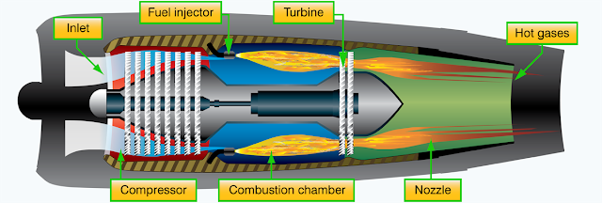 limited in range and endurance

Fig no. 7 turbojet engine

**4.2) Turboprop engine**: -

The Turboprop engine is a combination of a gas turbine engine, reduction gear box, and a propeller. Turboprops are basically gas turbine engines that have a compressor, combustion chamber, turbine, and an exhaust nozzle, all of which operate in the same manner as any other gas engine. However, the difference is that the turbine in the turboprop engine usually has extra stages to extract energy to drive the propeller. In addition to operating the compressor and accessories, the turboprop turbine transmits increased power forward through a shaft and a gear train to drive the propeller. The increased power is generated by the exhaust gases passing through additional stages of the turbine.

A turboprop engine is a turbine engine that drives a propeller through a reduction gear. The exhaust gases drive a power turbine connected by a shaft that drives the reduction gear assembly. Reduction gearing is necessary in turboprop engines because optimum propeller performance is achieved at much slower speeds than the engine’s operating rpm. Turboprop engines are a compromise between turbojet engines and reciprocating powerplants. Turboprop engines are most efficient at speeds between 250 and 400 mph and altitudes between 18,000 and 30,000 feet. They also perform well at the slow airspeeds required for takeoff and landing and are fuel efficient. The minimum specific fuel consumption of the turboprop engine is normally available in the altitude range of 25,000 feet to the tropopause. Approximately 80 to 85 percent of the energy developed by the gas turbine engine is used to drive the propeller. The rest of the available energy exits the exhaust as thrust.

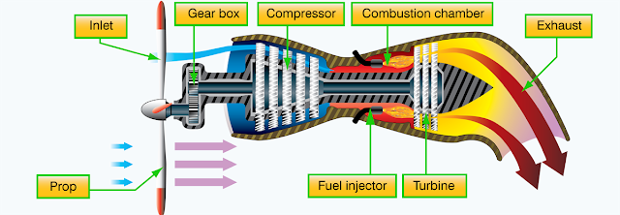The exhaust gases also contribute to engine power output through thrust production, although the amount of energy available for thrust is considerably reduced. Two basic types of turboprop engine are in use: fixed turbine and free turbine. The fixed turbine has a mechanical connection from the gas generator (gas-turbine engine) to the reduction gear box and propeller. The free turbine has only an air link from gas generator to the power turbines. There is no mechanical link from the propeller to the gas turbine engine (gas generator).

Fig no. 8 Turboprop engine

# **Advantages** of turboprop engine;

Very fuel efficient

Most efficient at mid-range speed between 250-400 knots

Most efficient at mid-range altitudes of 18,000-30,000 feet

# **Disadvantages** of turboprop engine;

Limited forward airspeed

Gearing systems are heavy and can break down

**4.3) Turbofan engine: -**

Turbofans were developed to combine some of the best features of the turbojet and the turboprop. Turbofan engines are designed to create additional thrust by diverting a secondary airflow around the combustion chamber.

So, almost all airliner-type aircraft use a turbofan engine. It was developed to turn a large fan or set of fans at the front of the engine and produces about 80 percent of the thrust from the engine. This engine was quieter and has better fuel consumption in this speed range. Turbofan engines have more than one shaft in the engine; many are two-shaft engines. This means that there is a compressor and a turbine that drives it and another compressor and turbine that drives it. These two shafted engines use two spools (a spool is a compressor and a shaft and turbines that driven that compressor). In a two-spool engine, there is a high-pressure spool and a low-pressure spool. The low-pressure spool generally contains the fans and the turbine stages it takes to drive them. The high-pressure spool is the high-pressure compressor, shaft, and turbines. This spool makes up the core of the engine, and this is where the combustion section is located. The high-pressure spool is also referred to as the gas generator because it contains the combustion section.

Two different exhaust nozzle designs are used with turbofan engines. The air leaving the fan can be ducted overboard by a separate fan nozzle, or it can be ducted along the outer case of the basic engine to be discharged through the mixed nozzle (core and fan exhaust together). The fan air is either mixed with the exhaust gases before it is discharged (mixed or common nozzle), or it passes directly to the atmosphere without prior mixing (separate nozzle). Turbofans are the most widely used gas turbine engine for air transport aircraft. The turbofan is a compromise between the good operating efficiency and high thrust capability of a turboprop and the high speed, high altitude capability of a turbojet. 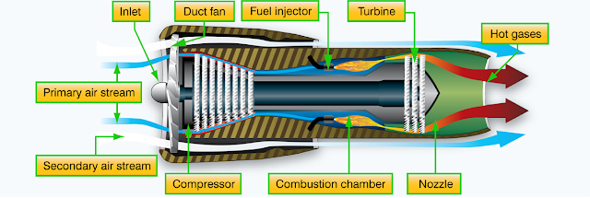

Fig. 9 turbofan engine

**#** **Advantages** of turbofan engine;

Fuel efficient

Quieter than turbojets

They look awesome

**# Disadvantages** of turbofan engine;

Heavier than turbojets

Larger frontal area than turbojets

Inefficient at very high altitudes

**4.4). Afterburning Turbojet:** To move an airplane through the air, thrust is generated by some kind of propulsion system. Most modern fighter aircraft employ an afterburner on either a low bypass turbofan or a turbojet. In order for fighter planes to fly faster than sound (supersonic), they have to overcome a sharp rise in drag near the speed of sound. A simple way to get the necessary thrust is to add an afterburner to a core turbojet. In a basic turbojet some of the energy of the exhaust from the burner is used to turn the turbine. The afterburner is used to put back some energy by injecting fuel directly into the hot exhaust. The nozzle of the basic turbojet has been extended and there is now a ring of flame holders in the nozzle. When the afterburner is turned on, additional fuel is injected through the hoops and into the hot exhaust stream of the turbojet. The fuel burns and produces additional thrust, but it doesn't burn as efficiently as it does in the combustion section of the turbojet. You get more thrust, but you burn much more fuel. When the afterburner is turned off, the engine performs like a basic turbojet.

# **Advantages**

Significantly increased thrust

# **Disadvantage**

very high fuel consumption

**5) Components of gas turbines engines:**

Major components of gas turbine engines: -

**5.1). Compressor**: - The compressor is used to pressurized (increase the pressure) of the incoming gas. There is the term "Pressure Ratio of a Compressor" which is defined as the ratio of the pressure of the gas coming out from the compressor to the pressure of the gas while entering the compressor. compressor used in turbine engines is generally of three types.

1) **Centrifugal flow compressors**: - In earlier times, Centrifugal Compressor was used and they are simple and less expensive. But Centrifugal Compressor has a low-pressure ratio and efficiencies as compared to the modern axial flow compressors. In small industries, Centrifugal Compressor is still in use. In this type of compressor compression is achieved with the help of centrifugal force.

2) **axial flow compressors**: -In axial flow compressors, the direction of the incoming gas is axial i.e. parallel to the direction of rotation, and also gas leaves the compressors axially. The shape of the blades of axial flow compressors is like twisted, highly curved airfoils because of which a tangential force on the fluid with the pressure exerted on one side is higher than on the other side. In Axial Compressors, two types of blades are their i.e. rotor blade (rotating blades) and stator blade (stationary blade).

Rotor blades are mounted on the central rotating shaft which rotates at high speed because of which rotor blades also rotate. Stator blades are connected to the outer casing because of which they are fixed and do not rotate. The main function of the stator blade is to convert the kinetic energy of air into pressure energy and maintain the direction of the flow i.e. parallel to the axis of rotation.

There is a term "Compressor Stage" which is defined as a pair of rotor blade and a consecutive stator blade. So, a two-stage compressor means it has two pairs of rotor and stator. Sometimes to achieve the desired pressure multi-stage compressor is used in this type of compressor compression is achieved axially with the help of rotary and stator. compression ratio of axial compressor are more than centrifugal compressors.

3) **centrifugal axial flow compressors**: -in this type of compressor we use both axial and centrifugal compressor to get more compression ratio.

**5.2). Combustion Chamber**: -It is also known as combustor. Pressurized air coming out from the compressor is now split into the two streams. The smaller stream goes directly into the combustion chamber where automized fuel is injected and mixed with and then burnt while the larger stream passes through the bypass given over the combustion chamber, so as to maintain the overall temperature of the gas that is suitable for the turbine inlet. In combustion chamber, all of this process takes place under constant pressure condition.

**5.3). Turbine**: - In a gas turbine engine turbine comes after the combustion chamber. It works on the reaction principle. Gas coming out from the combustion chamber expand on the turbine and exert force on the turbine blade which make the turbine rotate. There are two types of turbine i.e. high-pressure turbine and low-pressure turbine. So, during expansion of gas some part of the expansion takes place on high pressure turbine which will drive the compressor connected to it while the remaining part of the expansion on low pressure turbine which is connected to the outer load.

The turbine blades are used for special metallic alloy blades as very high temperature gas came in contact with it and also high centrifugal blade stress is generated.

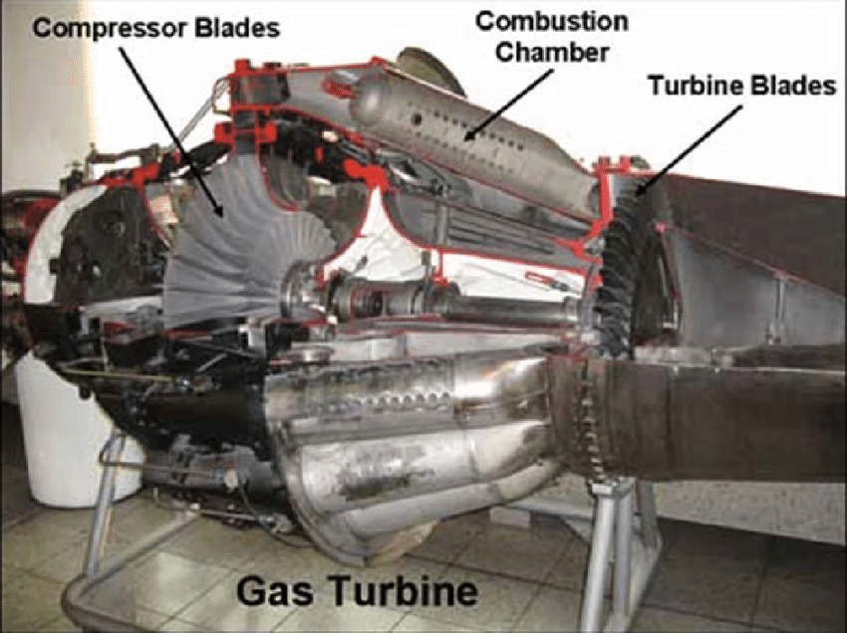Colder air is used to cool down the blades that have very high temperature, this colder air is directly taken from compressor.

Fig no.10 Gas Turbine

Two processes can be used:

(A) jet impingement on the inside of hollow blades

(B) bleeding of air through tiny holes to form a cooling blanket over the outside of the blades.

**5.4) Nozzle: -** Nozzle is duct of smoothly varying cross-sectional area in which a steadily flowing fluid can be made to accelerate by a pressure drop along the duct. Nozzle is the component of gas turbine which creates thrust. And for maximum thrust we need to get the maximum exhaust velocity which is provided by the nozzle.so nozzle is taken according to the jet engine. And the maximum velocity needed at the exhaust. There are three types of nozzle:

**1)convergent nozzle**: -A nozzle is a spot on the end of a hose or pipe used to control the movement of a fluid like water or air. A convergent nozzle is a nozzle that starts big and gets smaller-a decrease in cross-sectional area. As a fluid enters the smaller cross-section, it has to speed up due to the conservation of mass. To maintain a constant amount of fluid moving through the restricted portion of the nozzle, the fluid must move faster. The energy to make this fluid speed up has to come from somewhere. Some energy is in the random motion of molecules, which we observe as pressure. The energy in this random motion is converted into faster forward motion, known as stream flow. This change makes the pressure drop.

Convergent nozzle can increase velocity of incoming air up to Mach 1 only. If the speed of stream entering the nozzle is greater than Mach 1 then the convergent nozzle will decrease the speed

**2)divergent nozzle**: - a divergent nozzle has increasing area of cross section, as the fluid enters the nozzle than due to increasing area it has to reduce the speed to maintain the mass conservation. The energy which is released by decreasing speed must go somewhere it goes into increase the pressure. That’s why divergent nozzle is used to increase the pressure of the fluid. Although total energy of the system remains conserved.

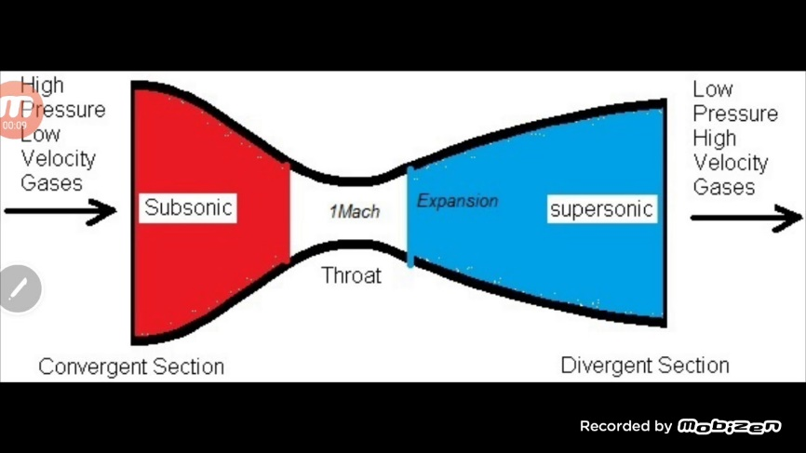Divergent nozzle decreases the velocity of fluid if the fluid is entering at velocity less than Mach 1. And it will increase the velocity of fluid if fluid is entering at velocity greater than Mach 1. So this is problem that for getting the supersonic velocities at exhaust we need to make the fluid speed at Mach 1 at entry. which is very problematic.

**Convergent-divergent nozzle:** The problem discussed above gets solved by convergent divergent nozzle. In this entry of fluid is at sub sonic speeds and at the throat it reaches the Mach 1(sonic flow). And after a diverging area is placed which is used to increase the speed of flow. The increase in speed of flow is dependent on the outer pressure. Outer pressure has to be equal to the atmospheric pressure to Fig no. 11 C-D nozzle

avoids shocks. So, for increasing the velocity we have to increase the area. And if exit area is increased then the weight of the gas turbine will be increased. So, it has to be optimized.

Applications of nozzle: -

* steam and gas turbines
* jet engines
* flow measurements

**5.5) Casing:** -

CASING is shell or cover which encloses the inside formations of engine. Its main function is to provide a path for fluids to flow. It does not allow crossflow of fluids from inside. It also protects the inside of engine. casing design is based on component. its design varies whether we are designing for compressor, for turbine or for combustion chamber. Here a general aeroengine casing is taken and design parameter taken are modal analysis. Modal analysis is basically vibration study of the structure to find the mode shapes and natural frequencies. Resonance will occur at natural frequencies when frequency of the system matches with the natural frequency of system. At resonance deformation of component is maximum and failure can occur. So, we design the system such that it does not resonate or when resonance occur deformation will be less. Vibration produce fatigue stresses due to material fails. so how we design for fatigue loading. We use finite element to do modal analysis of casing.

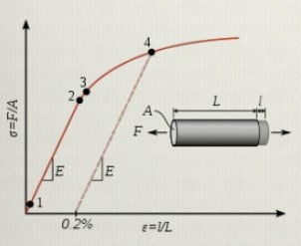**6) Stress-strain analysis**: - one main criteria for design is stress-strain analysis. In this it is checked whether the stresses acting on the body is not exceeding the failure limit of the material. For the purpose of failure limit, we take the yield strength or ultimate tensile strength. In the linear analysis we consider that hook’s law is valid it means the stress is proportional to strain. So, we can say that strain is cause and stress is result. It means if a body is deformed than internal resisting forces are produced. Which is called stress.

Fig no. 12 Stress-strain diagram

In region 1-2,

Hook’s Law is applicable i.e.

Stress ∝ Strain

E = Stress/Strain

E = Young’s Modulus or Modulus of Elasticity.

Material can regain its shape if stretched till point 2.

So if material passes through point 2 then it is considered to failed.

**7) Determination of stress and strain (theoretical): -**

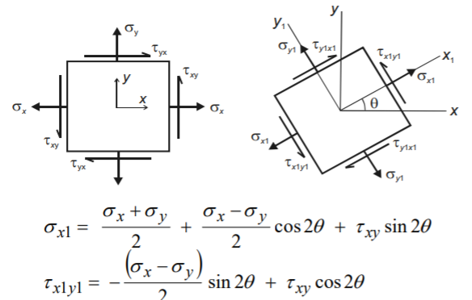 **7.1) Mohr circle:** Mohr’s circle is the graphical representation used for the evaluation of principal stresses, maximum shear stresses, normal and tangential stresses at any given plane. Where,

* $θ$ is the angle between the plane of interest and the principle plane,
* x is the normal stress on the stress element in x direction,
* y is the normal stress on the stress element in y direction,
* xy  is the shear stress on the stress element.

Mohr’s circle is plotted on x-y plane:

* On y axis, Shear stress is plotted Fig no.13 2d Stress element
* On x axis, Normal stress is plotted
* Eliminating 𝜃 by squaring and adding both the equations, we will get

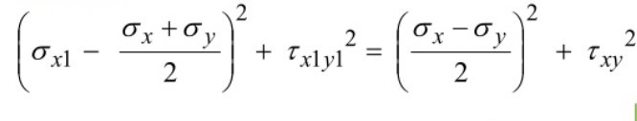----- (1)

Defining 𝜎avg and R,

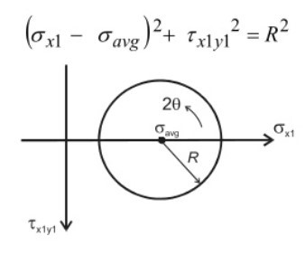 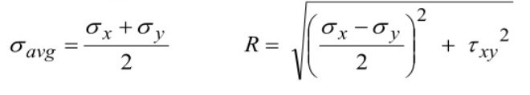-----(2)

Substituting equation (2) in equation (1), we get

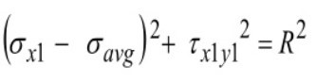----- (3)

This is equation of circle with center (𝜎avg,0) and radius R.

The circle drawn from this equation is known as the Mohr’s Circle.

**Mohr’s Circle**

From the equation we can see that the center of Fig no. 14 Mohr circle

the circle will be avg and the radius is R

We use this data to plot the Mohr’s circle as follows:

1. Draw the co-ordinate system with x1 as x axis (positive to the righthand side) and x1y1 as y axis positive downwards. Plot the co-ordinates A (x, xy) and B (y, xy) take the value xy to negative if counter clockwise.
2. On Mohr’s circle $θ$ is taken to be 2 $θ$ for plotting.
3. Join the two points A and B now taking the line AB as diameter draw a circle.
4. The point at which line AB meets x axis is the average normal stress and the points at which the x axis cuts the Mohr’s circle are principle stresses (which are perpendicular on the stress element).
5. To find the stresses on a plane at an angle $θ$ about the principle axis draw a line diametrical to Mohr’s circle at an angle 2 $θ$ from the x-axis
6. The co-ordinates at which this line cuts the circle will be the required stress values following the same sign convention.
7. Line parallel to y-axis and passing through the Centre of the circle gives the maximum and minimum shear stresses and the angle of maximum shear plane.

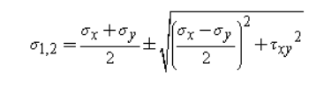

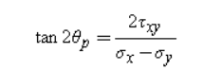 This is magnitude of principal stresses. This is the value of stresses in which only normal stress exists.

This this is the angle of principal plane from horizontal.

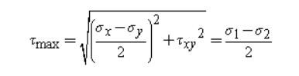

This is value of max shear stress. The angle of shear stress plane is +-450 from principal planes.

**8) Determination of stresses induced using strain gauge**: stresses produced are the reason that material will fail. Every material when we load it then it will deform. Due to deformation strain will produce. And due to strain stress will. And ultimately when stress is reached to limit value than the material will fail. So we have check the stress induced in material in the critical region. But there is no direct way to measure stress so we measure strain and with the help of which stress can be calculated. There are many methods to measure the strain. But using strain gauge is best method to determine strain induced in material.

**Strain gauge:** Measuring strain is a necessity to determine stress. Measuring strain under static loads is a very easy task but when it comes to measuring strain in a vibrating casing we need a special apparatus called strain gauge Strain Gauge is a sensor that measures the strain on objects or structures at the point of attachment. In real life, the structure is of such a complex shape that the determination of stress becomes very difficult at every point. So, strain is determined with the help of strain gauge and then the measured strain is multiplied by the modulus of elasticity in order to determine the change is stress. Because we consider that hook’s law is valid.

Stress(𝜎) = Strain(𝜀) X Modulus of Elasticity(E)

Strain Gauge is attached to structure or object with the help of adhesive such as Cyanoacrylate.

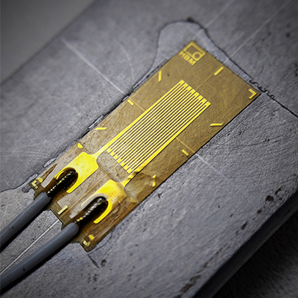

Fig no. 15 Strain gauge

As shown in the figure, Strain gauge has several loops of metallic wire (grid) fixed in between two end loops, these end loops are attached to solder tabs which are used to connect the strain gauge with measuring apparatus, all of this arrangement is fixed on a backing material which has alignment marks on it (horizontal and vertical to the grid).

Strain Gauge works on the principle that as the length of the metallic wire increases or decreases, their will a change in resistance of the metallic wire.

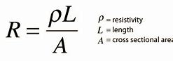

Strain Gauge has a long and thin conductive wire arranged in zig-zag form because it doesn't increase the sensitivity of the strain gauge since the percentage change in the resistance for this zig-zag form is the same as that of the single strip. **The sensitivity of a strain gauge is also known as the gauge factor, represented by a letter 'G'.**

G = [ΔR / (Rg * ε)]

Where,

ΔR = Change in the resistance caused due to strain.

Rg = resistance of the undeformed gauge.

ε = Strain in the wire of gauge.

and,

ε = (L2-L1)/L1

Where,

L1 = original length of wire.

L2 = new length of the wire

Gauge Factor of different materials is as follows

Material Gauge Factor

Metal foil strain gauge 2-5

Thin-film metal (e.g. constantan) 2

Single crystal silicon -125 to + 200

Polysilicon ±30

p-type Ge 102

Thick Film Resistors 100

So, the Gauge Factor of the strain gauge is known, and to find the value of the strain(ε), the value of ΔR /Rg must be known. To find the value of ΔR /Rg, the strain gauge attached in the **Wheatstone bridge.**

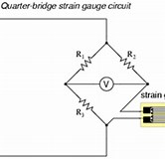If one of the resistors is replaced with the strain gauge, then the circuit bridge is known as **Quarter bridge.** similarly, if two resistors are replaced with two strain gauge then it is known as **half-bridge.**

Fig no.16 Strain gauge circuits

Similarly, if all four resistors are replaced with four strain gauge then it is known as **full-bridge**

The Wheatstone bridge consists of 4 arms having one resistor each along with a voltmeter, which is attached between two diagonally opposite nodes and shows the output voltage. When the bridge is in a balanced condition, that means no current is flowing through the voltmeter, so the output voltage comes out to be zero. But if resistance in any one of the resistor changes then the bridge will become unbalanced and the voltmeter will show some output voltage(𝑉out) 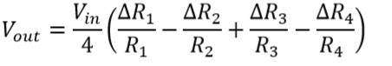 Let's say 𝑅1 is replaced with strain gauge and other resistances are known along with the input and output voltage, so easily ∆𝑅1/𝑅1 can be calculate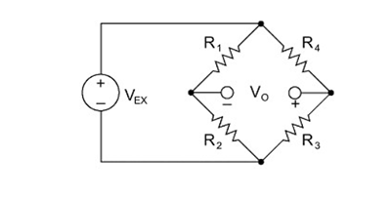d

But the output voltage is small of the order of microvolts which is very difficult to note so the Voltage amplifier is used to amplify the output voltage(𝑉out) magnitude to a considerable value(𝑉amp). The amount by which the input voltage is amplified is known as the Amplifier Gain (Ag).

Amplifier Gain (Ag)= 𝑉amp/ 𝑉out

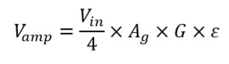Amplifier gain value is set in such way that for 1mv of voltage we get 1 micro strain in material

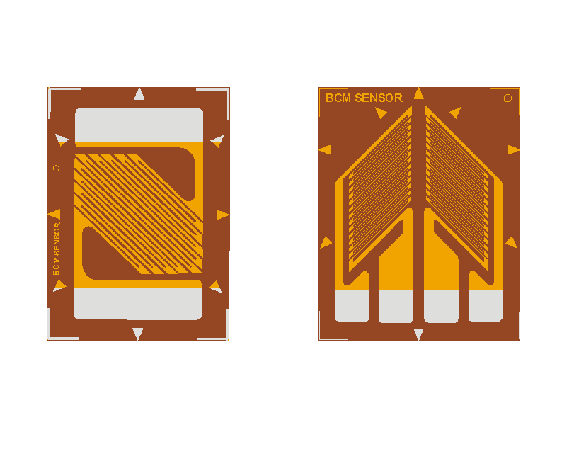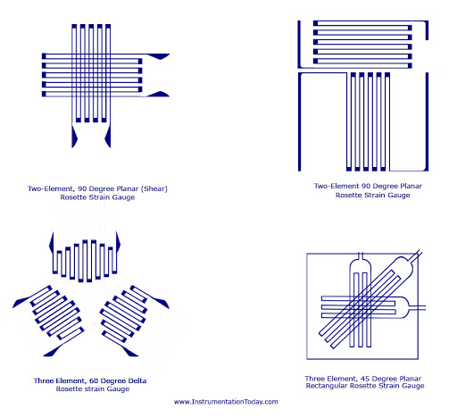A single grid strain gauge insensitive in lateral direction i.e., cannot read any lateral strains so for this problem we use 2-rosette strain gauge or biaxial strain gauges (inclined at 90 with each other). Also aligning the strain gauge in the longitudinal direction is very tiresome so a 3-rosette strain gauge can be used to get accurate readings where alignment is difficult. Both of these are available in two types normal and stacked type. Normal type rosettes are used where less precision is required as they give the readings at two different points and also, they occupy large space, but they don’t get heated up quickly. In case of stacked rosettes, the readings are precise and accurate, gives the strains at almost single location but gets heated up as there is very less area for heat dissipation.

Fig no. 17different type of strain gauges

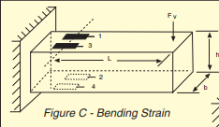**9) Positioning of Strain Gauge: -**

* In case of Bending Load:

4 Strain gauges are used such that: Two are placed on the top Two in bottom All of them parallel to the axis

* 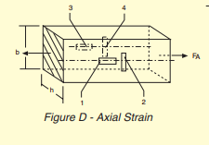In case of Axial Load:

4 strain gauges are used such that: Two are placed on one surface and perpendicular to each other. Other two are placed on the surface opposite to previous and are perpendicular to each other.

* In case of pure shear:

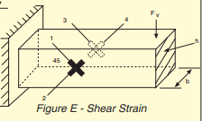 Maximum stress is at 450 to the principle axis 4 Strain Gauges are used, placed at 450 to the principle axis.

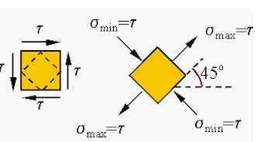

* 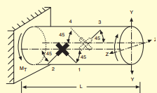In case of torsional load:

In this case, Maximum stress lies at 450 to the axis 4 Strain Gauges are used, placed at 450 to the axis.

* 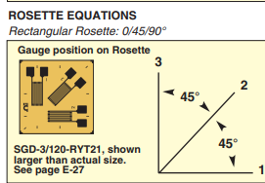In case of thin cylindrical vessel:

In thin cylindrical vessel, there are two type of stress i.e. Hoop stress and Radial stress, which are perpendicular to each other. So, we use T-Rosette to measure the strain.

After determining the strains, it need to be checked that material is failing due to that stress or not.

Fig 18. Positioning of strain gauges

**10) Theories of Failure:** **-**

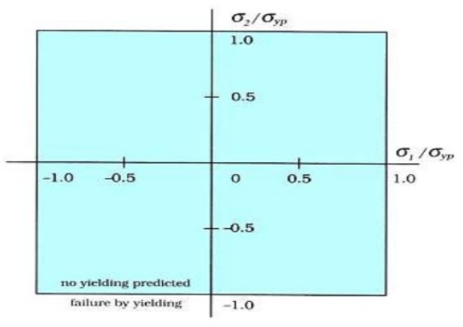 There are 5 theories of failure:

**10.1). Maximum Principle Stress Theory (Rankine Theory): -** According to this theory, when the maximum principle stress reaches the yield stress of that material then the material will fail i.e.

if σ1 ≥ σyt , then material will fail

if σ1 < σyt , then material will not fail

Fig 19. Rankine

Using the above condition, graph is plotted as shown. In graph, if value lies within blue region then material will not fail.

This failure theory is used for brittle material.

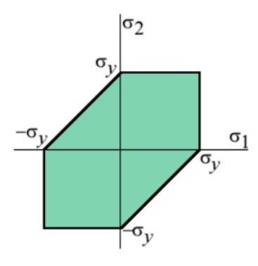**10.2). Maximum Shear Stress Theory (Tresca Theory): -**

According to this theory, when the maximum shear stress in actual case reaches the maximum allowable shear stress of the material (Half of the yield strength) then the material will fail.

[τ](https://en.wikipedia.org/wiki/Tau)max, actual = (σ1- σ2)/2 [τ](https://en.wikipedia.org/wiki/Tau)max,allowable = σyt/2

If |(σ1- σ2)/2| ≥ σyt/2 then material will fail.

Using this condition graph is plotted as shown. In graph, if value lies within green region then material will not fail. Fig no. 20

This failure theory is used for brittle material.

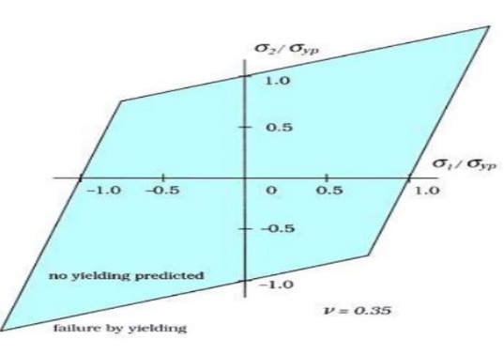**10.3). Maximum Principal Strain Theory (Saint-Venant Theory): -**

This theory states that when the principal strain in actual case is more than the maximum normal strain in simple tension then the material will fail.

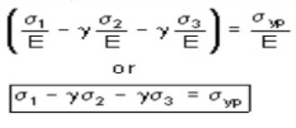 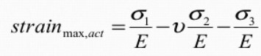

From the above, Failure condition is:

Using this equation graph is drawn as shown above. Material will be same if lies with blue region.

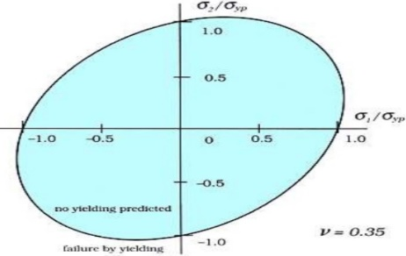**10.4). Maximum Strain Energy Theory (Haigh Theory): -** According to this theory, Material will fail when the total strain energy per unit volume in actual case in more than the total strain energy per unit volume at yield stress. So, the condition become Above equation is plotted on the graph as shown above. Material will not fail if lies within the blue region.



This failure theory is used for ductile material.

**Fig 21. Haigh theory**

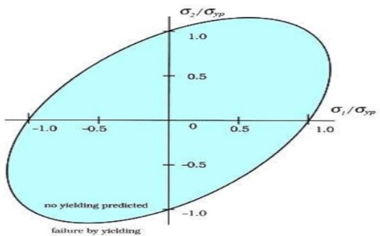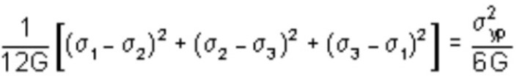**10.5). Maximum Distortion Energy Theory (Von Mises Theory): -**According to this theory, material will fail when distortion energy per unit volume under given load reaches the maximum distortion energy at yield stress.

G = modulus of rigidity

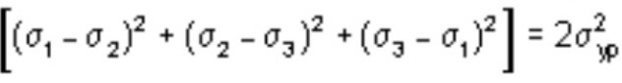 On further solving above equation, we get Fig. 22 von mises theory

For biaxial loading,

Put σ3 = 0, we get



Plotting above equation on the graph is shown above. If lies within the blue region material will not fail. This failure of theory is used for ductile material.

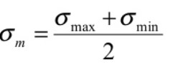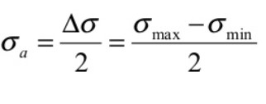**11) Fatigue:** - The type of failure in the material when it is subjected to cyclic loading or stress is known as fatigue. Under the effect of fluctuating stress, a point comes where the material is fractured, and this level of stress is called fatigue stress. The fatigue stress is lower than the yield stress of that material. This type of failure is like brittle in nature even in ductile material as material fracture without any proper indication. Fatigue failure can be observed in many situations like loaded rotating machineries where the bending stress are reversed with every rotation. The very big reason for fatigue failure is vibration because in variation of stresses on material is cyclic, due to harmonic oscillation. The **mean stress value** and **alternating stress value** is: -

**11.1) Factors causing fatigue failure:** -

* Large amount of variation in applied stress.
* Magnitude of **maximum tensile stress** is very high.
* Large **number of cycles** of applied stress.
* Presence of **stress concentration points** such as sharp corner and notches.
* Presence of **surface cracks** as it causes fatigue failure to occur more rapidly.
* If the **residual stress** is tensile in nature then fatigue failure will occur rapidly and residual compressive stress will reduce fatigue.
* **Corrosion** as due to corrosion the surface layer become weak because of which fatigue failure will occur rapidly.
* **Casting defects** such as porosity, non-metallic inclusion can reduce the fatigue strength.
* Fatigue life will reduce if the **temperature** is increased.

**Fatigue life (N): -** It is the total number of cycles of fluctuation stress after which the material will fail due to fatigue.

**S-N curve: -**S-N curve is a very useful way to visualize the fatigue failure of a specific material. S-N curve is plotted using the stress amplitude(S) on the vertical axis and number of cycles(N) to failure on the horizontal axis.

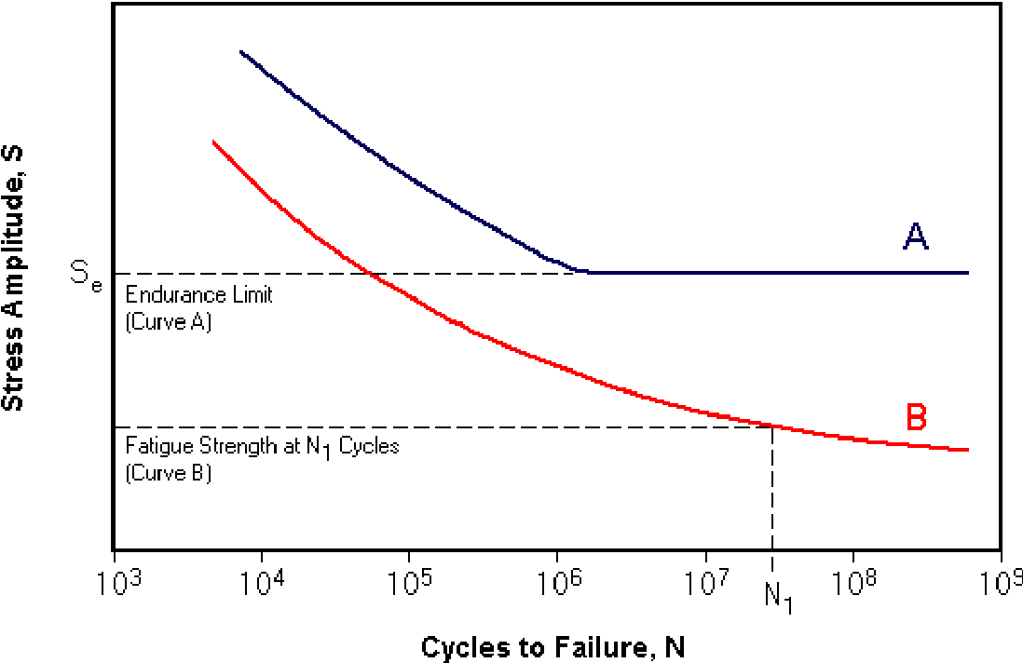

Fig. no. 23 S-N curve

In the figure, curve A represent the S-N curve of ferrous material and curve B represent the S-N curve of non-ferrous material.

For ferrous material, **Endurance limit** is defined and for non-ferrous material, **Fatigue strength** is defined.

**Endurance limit** is defined as the maximum value of the cyclic stress below which the material will not fail for the infinite number of cycles. It can be clearly seen in the figure that the curve A become horizontal below the stress ‘Se’ which means that ‘Se’ is the endurance limit of the curve A.

**Fatigue strength** is the magnitude of the cyclic stress at which the failure will occur for the specified number of cycles. Generally, the number of cycles is 107 .

**11.2) Design criteria for fatigue:** -In the practical situation, most of the machine part is subjected to both steady stress (Savg) and reversing stress (Sr). The above stress-time graph shows this combined reversing and steady stress condition. If the stress is varying between Smax & Smin, then the

Steady stress = Savg = (Smax +Smin)/2

Reversing or alternating stress = Sr = (Smax -Smin)/2

There are many criteria for design

**1) SODERBERG’S CRITERIA:**

1. 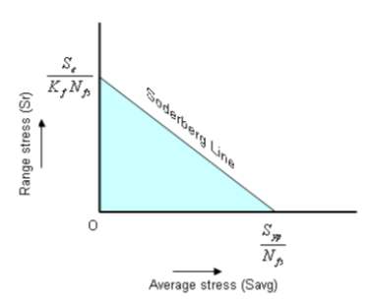When there is no alternating stress (Sr = 0) i.e., at static conditions in order to prevent failure :

$$S_{avg}<\frac{S_{yp}}{N_{fs }}$$

Where Nfs is factor of safety and Syp is yield point stress.

1. Similarly when there is pure alternating stress i.e., Savg = 0 , then to prevent failure :

$$S_{r}<\frac{S_{e}}{N_{fs}K_{f}}$$

Where Se is the endurance limit or fatigue strength and Kf  is the stress concentration factor.

On plotting both the points taking average stress on x-axis and alternating stress on y-axis and joining the two points we have a straight line, this is called soderberg’s line. When there is combined stresses (Sr and Savg) there designer should only consider the combination of stresses below the line in the region as shown for the design to be safe.This blue region can be define by using line eqution as:

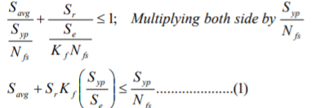

This equation is called Soderbergh’s equation. In this equation the R.H.S is static component and 1st part of L.H.S is also static or steady stress the 2nd component of L.H.S is the static equivalent of alternating stress.

**2) GOODMAN’S CRITERIA:**

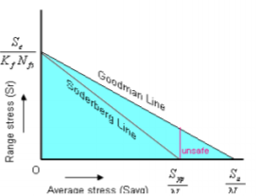As the fatigue failure is brittle in nature, Goodman proposed that ultimate tensile strength can be considered instead of yield strength in Soderbergh’s equation for the design to be safe. Goodman’s equation can be obtained by replacing yield strength with ultimate tensile strength in soderberg’s equation.

the drawback of this criteria is that when the average stress exceeds Syp/Nfs the material may fail due to plastic deformation. That unsafe zone is marked in the image.

**3) MODIFIED GOODMAN’S CRITERIA:**

As mentioned above goodman’s criteria has the draw back so, to overcome this problem a line of 45 angle from the Syp/Nfs point on the x-axis to y=axis. The region so formed due to 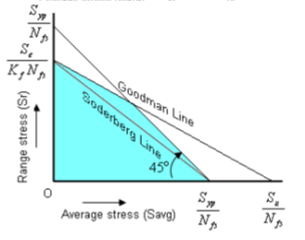the intersection of all these lines is the safe region for the design. This is called Goodman space, this satisfies the following equations



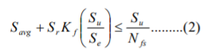

**12) Vibration**: - vibration is the phenomenon where oscillation occur about an equilibrium position. These oscillations may be periodic or random. Periodic vibration like motion of pendulum. Random vibration like motion of bike on uneven road. Vibration can be pretty useful in some devices like accelerometers, mobile phones, loudspeakers and many more. But in most cases, it is undesirable. Due to which it wastes energy, produce sound and do the fatigue failure of components. Fatigue failure is very important aspect of vibration. Vibration produces the cyclic stresses on material. Due to which material fails by fatigue failure. So, we design the product in such a way fatigue stress does not fail the structure

There are two types of system: -

**1)linear system**: - it implies that response of each of the component of system like acceleration, velocity, acceleration etc. have a linear relationship with the applied force. We use Fourier analysis; Laplace transform these all are valid for linear system so in this we are taking linear system only.

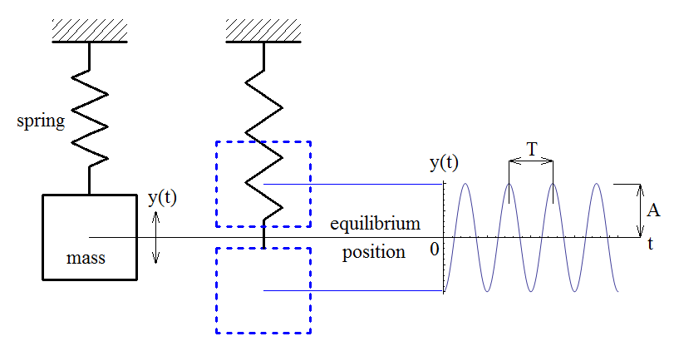**2)Nonlinear system**: -in this response of component are not linear so we call them nonlinear system normally it considered that if a system is showing nonlinear behavior than it considered as bad design.

**13) vibration in 1 DOF system: -**

**13.1) Free vibration**: when the system only disturbed once then it will start to vibrate freely. The system can vibrate at one or more of its natural frequencies or at superposition of normal modes. Which depends on the system components like mass and stiffness. For example, in 1 degree of freedom system. When we deflect the mass then it will start to oscillate at natural frequency. Which is equal to (ωn)2=k/m. this is the natural frequencyof1 dof system. Damping is considered to be zero because there is no outside impact on the system.

equation of motion:-

ma + kx = 0

so, it is differential equation by solving we know that it is SHM.

So natural frequency (ωn)2= k/m

So the system will vibrate at this frequency.

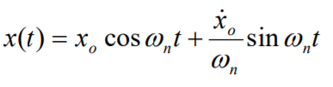from this equation of displacement, we can see that oscillation of mass will depend on the initial conditions like displacement from equilibrium and velocity of mass and system will vibrate at natural frequency.

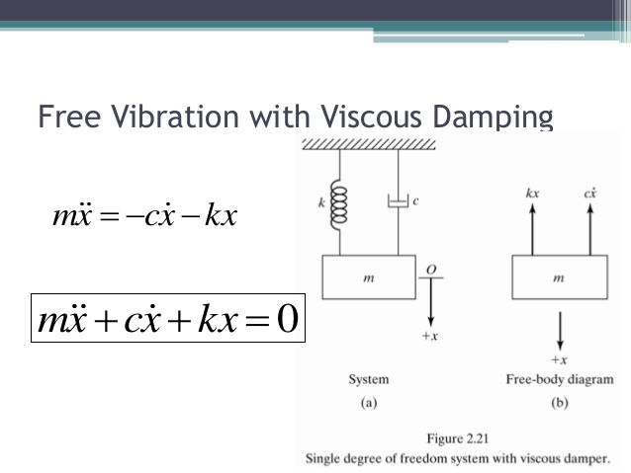**13.2) Damped vibration**:- when there is reduction in amplitude of vibration due to losses present in system is called damped vibration. It occurs due to the friction present in the system. It is very useful nature for example shock absorbers of bike. In this system will vibrate at damped natural frequency and amplitude degrades over time and become zero at the end

Consider the spring‐mass system with an energy dissipating mechanism described by the damping force as shown in the figure. It is assumed that the damping force is proportional to the velocity of the mass, as shown; the damping coefficient is c. When Newton’s second law is applied, this model for the damping force leads to a linear differential equation

Damping force = cv Fig. damped system

C = damping coefficient (damping force per unit velocity)

ωn = frequency of natural undamped vibrations

a + (c/m) v + (k/m) x = 0

α1,2 = -(c/2m) ± ((c/2m)2-(k/m))0.5 It is solution of differential equation. With the help this displacement can be found.

Degree of dampness =(c/2m)2/(k/m)

Damping factor ξ = c/(2√km)

Damping coefficient c = 2ξ√km = 2ξmωn = 2ξk/ωn

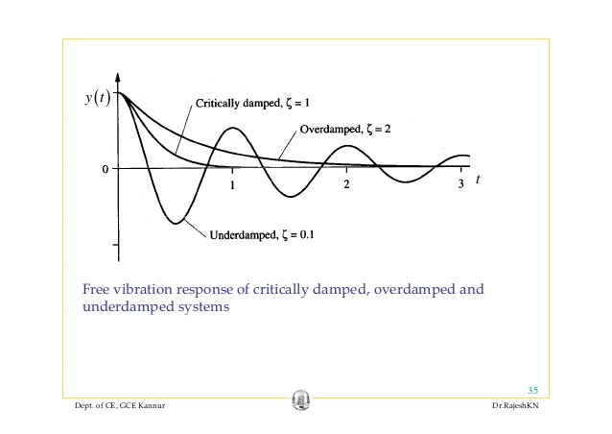 ξ > 1 the system is over damped: in this case restoring factor is less than the damping factor. So there is no vibration at all just there is decrease in amplitude of system

When ξ = 1, ωd=0, time period of vibration= ∞ damping is critical, thus under critical damping conditions the return of system is very fast that therefore it is used in trigger mechanism of guns.

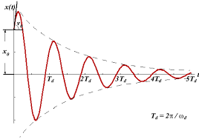ξ < 1; the system is under damped: in this case restoring energy is more than damping energy so there is vibration but its amplitude is decreasing in nature and at finally becomes zero.

Fig. Under Damped response

ξ = 2√km = 2mωn = 2k/ωn

ξ = c/cc = Actual damping coefficient / Critical damping coefficient

ωd = ωn√ (1-ξ 2) It is known as the damped natural frequency. system will vibrate at this if it is given any excitation.

When ξ=0, ωd = ωn, means it is the case of free vibration

**13.3) Forced vibration**: - the tendency of one object to move the other object with same frequency of vibration is called forced vibration. In this is given to system due to which system start to vibrate at same frequency as the excitation. This excitation can be given by different ways

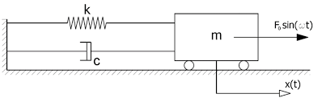 Fig. Forced system

* External forcing: in this excitation is given to mass. for example, offshore object facing forces due to waves.
* Base excitation: this can be used to model the isolated system. In this excitation is given to the spring base. This can be used to model the structure response of earthquakes.
* Rotor excitation: In this a rotating mass is attached to the mass. So there is rotor excitation. This can be used to model mass on crankshaft.

There are other types of excitation also but almost all the other systems can be simplified into these system

Equation of motion by newton law of motion

a + (c/m) v + (k/m) = f(t)

f(t)= Fosin(ωt)

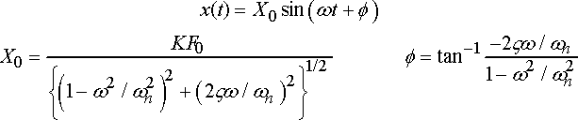Here we are considering only harmonic oscillation because of linearity in system. Here f(t) is external disturbance which we can consider to be as harmonic f(t)= fosin(ωt) here ω is frequency of disturbance the system will vibrate at this frequency. the amplitude of the vibration depends on the damping coefficient and frequency ratio.

In the forced vibration the response of the system is transient in nature and after some time it becomes steady in nature. It is because initially we give some conditions like velocity and displacement from equilibrium position because of which first the external force has to cope up with the initial conditions and after some time it comes in sync with the external force and start to behave in that respect. So, in forced vibration of system does not depend upon initial conditions rather depend on frequency ratio and damping conditions.

**13.3.1) Magnification factor:** - it is ratio of maximum displacement(xmax) of forced vibration to static deflection(xo) due to fo

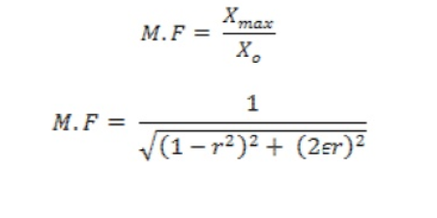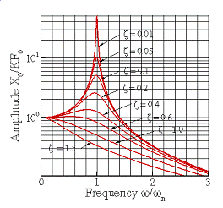graph of magnification factor with frequency ratio

frequency response diagram

from this graph it can be seen that when the frequency ratio is 1 then magnification factor reaches to its maximum. So, amplitude of vibration reaches very high due to material can fail. This phenomenon is known as resonance. It happens when frequency of disturbance reaches to natural frequency.

ω = ωn this condition is very dangerous. Therefore, it is always tried that structure never works at resonance

As a general rule, engineers try to avoid resonance like the plague.  Resonance is bad vibrations, man.  Large amplitude vibrations imply large forces; and large forces cause material failure.  There are exceptions to this rule, of course.  Musical instruments, for example, are supposed to resonate, so as to amplify sound.  Musicians who play string, wind and brass instruments spend years training their lips or bowing arm to excite just the right vibration modes in their instruments to make them sound perfect.

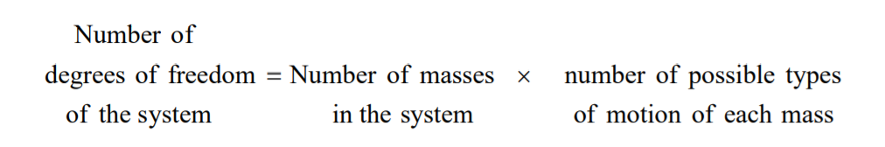**14) 2 dof spring mass system**: - Systems that require two independent coordinates to describe their motion are called 2 degree of freedom system.

2 dof system has two natural modes of vibration. Means there are two frequencies at which the system can vibrate. So, no. of modes of vibration are equal to no. of degree of freedom of system

So, a continuous system has infinite no. of modes of vibration. In continuous system we have to solve partial differential which is very is very difficult so we solve them using FEM method. Equation of motion of 2 dof system: The motion of the system is completely described by the coordinates x1(t) and x2(t), which define the positions of the masses m1 and m2 at any time t from the respective equilibrium positions.

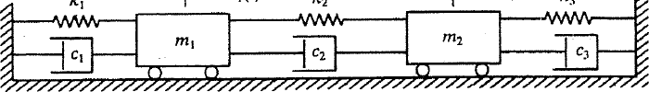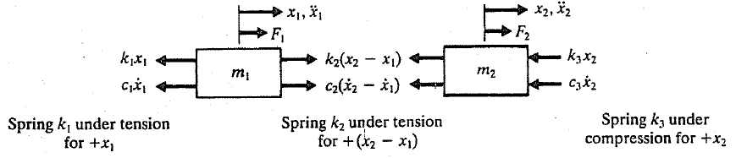

**Fig. forced vibration system**

Equations: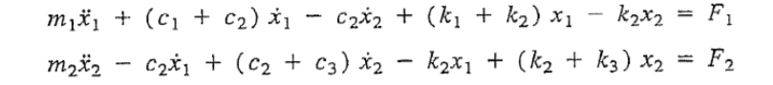

So these equations can also be written as in matrix form:



where [m], [c] and [k] are mass, damping and stiffness matrices, respectively and x(t) and F(t) are called the displacement and force vectors, respectively. Which are given by:

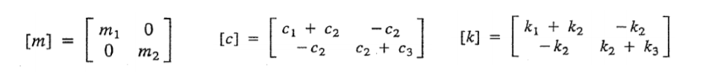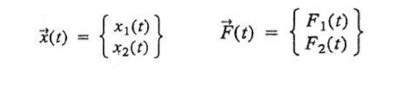So, these equations can also be written in multi dof system in matrix form

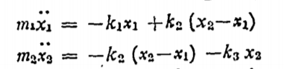To find the natural frequencies of system we need to consider the undamped free vibration so by considering that we can say that damping is zero and there is unbalanced force .so the final equation becomes

Now we are considering harmonic motion so

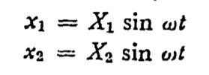

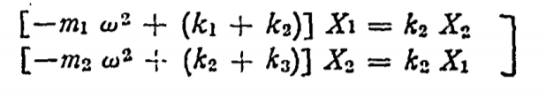substituting this value in first equation

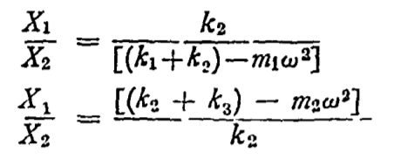by rearranging above equation we get

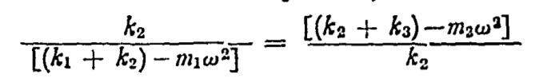

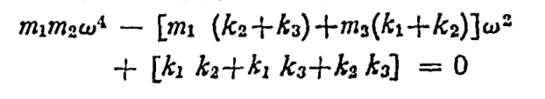 By solving this we get

So this is the quadratic equation of w2 . so we two values of natural frequencies

Now for a special case put k1=k3=k and m1=m2=m we get

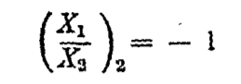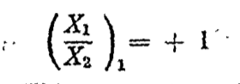 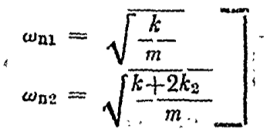by putting the value of natural frequencies we get ratio of amplitudes which can be seen that in first mode both are in phase and ratio is one but in second phase they are out of phase and ratio is -1.

So natural mode will only occur if we give this displacment to the masses. If the displacement given is not in this ratio than a superposed mode of both natural modes will occur. So the masses will do general motion.

So equation of general motion of masses under free vibration is 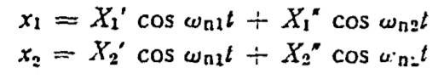

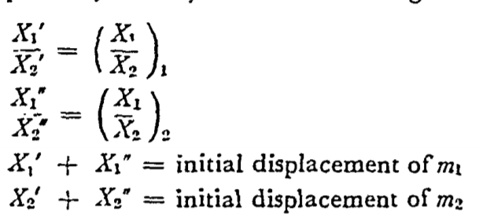 Here x1’ and x2” are amplitudes of mass m1 at lower and higher natural frequencies. Similarly x2’ and x2” are amplitudes of vibration at lower and higher natural frequencies.

**15) Multi dof system:** In this there are multiple no. of freedom. So, there are n natural frequencies. So, there are n no. of modes. So here we have to solve the differential equation get the natural frequencies and modes of structure. So now for multiple degree of freedom system we can do modal analysis.

Modal analysis is just finding the natural modes shapes of vibration so that we can predict how much stresses and deformation can occur at natural frequency and how will the system will behave.

As we know that most engineering material are continuous materials. So in continuous system there form partial differential equations which are very difficult to solve. So we have to convert them to ordinary differential equations. To convert them to ODE we have to divide continuous structure to discrete structure.

So, for multi dof system having n degree of freedom. There are n mode shapes and associated natural frequencies.

**15.1)There are different methods to convert continuous system to multi dof system.**

1). A simple method involves **replacing the distributed mass** or inertia of the system **by a finite number of lumped masses** or rigid bodies. These lumped masses can be connected with the members having stiffness and damping characteristics. The no. of coordinates required to determine the motion of masses are equal no. of degree of freedom of system. If no. of lumped masses taken are more then the result analysis becomes very accurate.

We can take one example to demonstrate this like a three storey bulding can be assumed as three mass system with elastic and damping member. So this problem can be easily solved.

Many other problems can also be simplified by this.

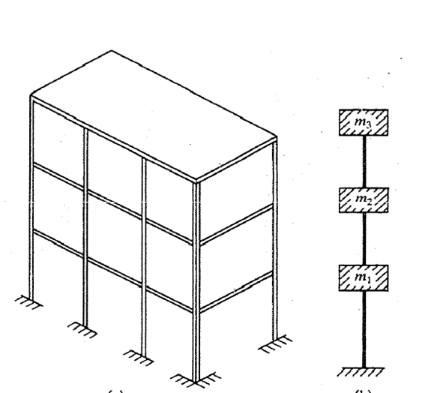

Three storey building

2) Another method of converting the continuous system into discrete form by dividing the structure into small elements. We can solve for complete geometry by solving within the elements and principal of compatibility and equilibrium can be used to find for the original system. This method is known as **finite element method.**

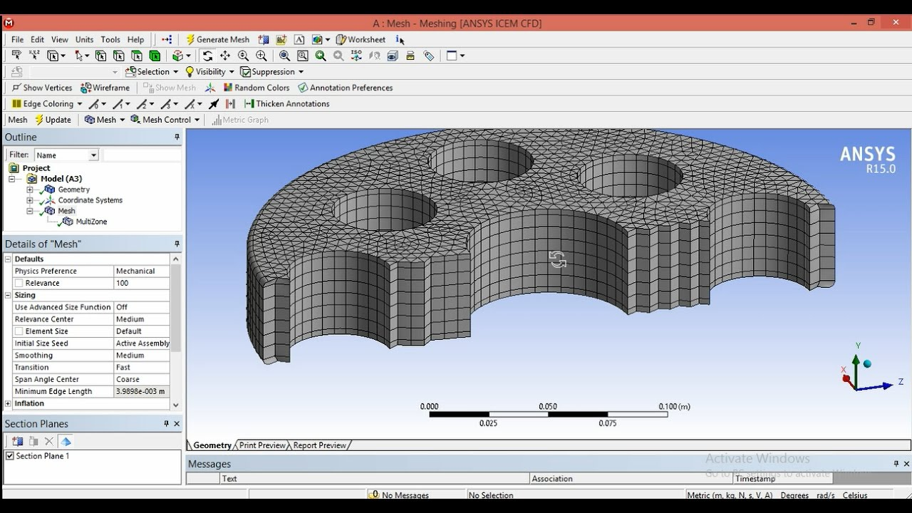

Equations of motions for multi degree of freedom system:

1. First describe the coordinate system for masses and assume suitable coordinates of all the masses. Now assume initial displacements, velocities and forces on system of masses.
2. Now determine the static equilibrium position of system and determine the static equilibrium position of masses.
3. 3) Now draw the free body diagram of the masses and newton’s law of motion.

here xi is the distance measured from respective equilibrium postions.

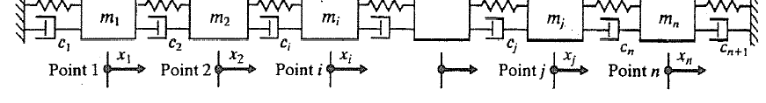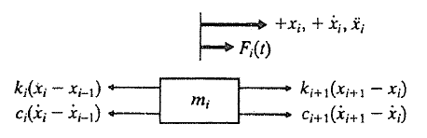

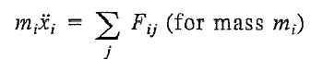Equation of motion represented in matrix form learned from earlier discussion

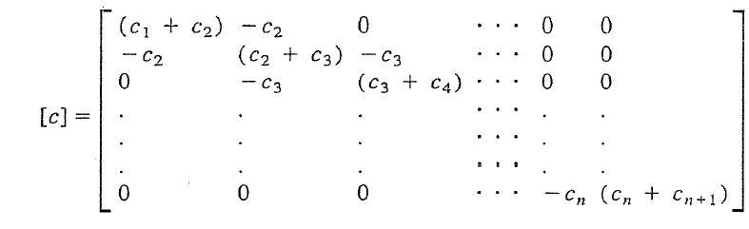

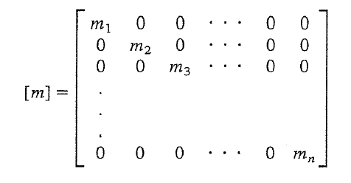

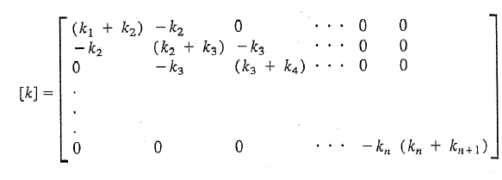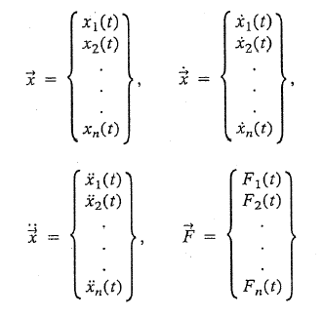

Now for most systems we consider damping to be negligible so for modal analysis we consider undamped free vibration and find out the natural frequencies and mode shapes of the structure. So, if we vibrate that structure at that frequency it will resonate.

So now these equations have to be solved simultaneously to get the mode shapes and natural frequencies.

By analogy with the behavior of SDOF systems, it will be assumed that the free‐vibration motion is simple harmonic (the first equation below), which may be expressed for a multi degree of freedom system as:

**x**(*t*)  **x**ˆ sin(*t*  ** )

**x**  ** 2**x**ˆ sin(*t*  ** )  ** 2**x**In the above expressions, **x**ˆ represents the shape of the system (which does not change with time; only the amplitude varies) and  is a phase angle. The third equation above represents the accelerations in the free vibration.

Substituting above equations in differential equation we obtain

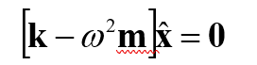 -*2* **x**ˆ *msin(t+* *) + k* **x**ˆ sin(*t*  *) = 0*

**The** equation is known as characteristic equation for **eigen values problem.** The quantities ** 2 are the **eigenvalues or** characteristic values indicating the square of the free‐vibration **frequencies**, while the corresponding displacement vectors **x**ˆ express the corresponding shapes of the vibrating system‐ known as the **eigenvectors** or mode shapes. Now this is eigen value problem. So determinant of term inside the brackets must be zero. So with the help of which we can find the eigen values of equations .

The above equation is called the frequency equation of the system. Solving the determinant we will give us natural frequency. We will get n natural frequencies (ω12, ω22, ω23…………ωnn) the vector corresponding to this are mode shapes.

Modal analysis can be done for free and constrained. example of free system is boat moving in sea full of waves and constrained example is cantilever beam fixed at one end.

**The Modal Domain**  
The modal domain is one perspective for understanding structural vibrations. Structures vibrate or deform in particular shapes called mode shapes when being excited at their natural frequencies. Under typical operation conditions a structure will vibrate in a complex combination which consists of all mode shapes. However, by understanding each mode shape the Engineer can then understand all the types of vibrations that are possible. Modal analysis also transfers a complex structure that is not easy to perceive, into a set of decoupled single degree of freedom systems that are simple to understand. Identification of natural frequencies, modal damping, and mode shapes of a structure based on FRF measurements is called Modal Analysis.

For example, if a simply supported beam is excited at its first natural frequency, it will deform by following its first mode shape. This first mode is also called V mode as illustrated in Figure 1.

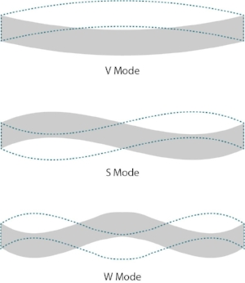The beam will move back and forth from the position shown in solid line to the position shown in dashed line. If the beam is excited at the second natural frequency the second mode shape will be excited, which is often called the S mode. If the beam is excited at a frequency between the first two natural frequencies then the deformation shape will be some combination of the two mode shapes. The third mode shape is often called the W mode. As the mode number goes higher, more node points will be observed. Dynamic analysis of finite element method can be used to predict the vibration characteristics of a structure under design.  The structure is represented by a theoretical collection of springs and masses and then a set of matrix equations can be written that describes the whole structure. Next a mathematical algorithm is applied to the matrices to extract the natural frequencies and

Fig. Mode shapes of beam

mode shapes of the structure. This technique is used to predict the modal parameters before a structure is manufactured to find potential issues and address them early in the design process.

**15.2) Applications of modal analysis: -**

1. Modal analysis is used for troubleshooting purposes of the structures. so that we can repair the structure in such a way that it will not fail. And the forced frequency does not become equal to the natural frequency
2. It is used to predict the actual response of a structure under forces for example vibration of motor vehicle on the tracks even before the vehicle is moving by doing the modal analysis and then predicting for the forces
3. In musical instruments we use the modal analysis to check the dynamic response of speakers.

16) **Casing**: It is the structure that encloses the inner of the aeroengine. Main criteria for design of casing is the vibration analysis. The vibration analysis of the casing is not only necessary for casing design but it is also important for the other parts of the engine. Because the source of vibration in casing is rotor-casing system. Aero engine has a very complex system. Which produce a very wide variety of vibrations. So casing is used for vibration monitoring of the aero engine. The measurement of vibration at moving parts is difficult. So what we do we put sensors on the casing by them we can measure the vibrations on casing. and with the help of theoretical model of rotor casing system we can tell the vibration response of the rotor system. The rotor system is the core component of the gas turbine engine. These sensors are installed in close proximity to the bearing support region to minimize the energy attenuation of the rotor vibration transmitted to the casing vibration point. It is generally believed that the vibration measurement section is mainly selected according to the casing section of the supporting bearing. So, by it can be seen that casing is very important part of aeroengine to study vibration.

**16.1) Reason of vibration produced in casing**: Vibration are produced in casing in due the motion of the rotors in the system. On the rotor shaft system there are cyclic forces acting on the shaft and these forces are transmitted to the bearings from bearing these excitations gets transferred to the casing. So, the casing will vibrate. So, to study the vibrations in casing we have to study rotor dynamics.

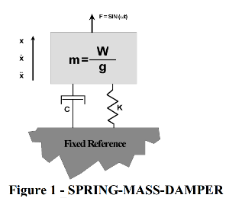**16.2) Rotor dynamics**: Rotor dynamics is very interesting and complicated subject. It is very difficult to model a rotor system. It is the study of behavior of rotating objects. It includes components ranging from steam turbine to the jet turbine. A rotor may have its natural frequencies excited by many sources: rotating imbalance, rubs, or process changes such as surge. The first objective of rotor dynamics is to identify the resonant frequencies present in a system, determine their severity and, if necessary, design the system around them. The most basic system of rotor dynamics is a mass is supported in some sort of bearing. This system can be shown analogous to spring mass system with damper.

Ma + Cv + Kx = F this is the governng equation of the system . this equation has very big implication. In this equation we can see that forcing function is opposed by only three things: inertia of system,stiffness of spring,damping in system.

At low frequency the system response is controlled by stiffness.

At critical speed of shaft where forced frequency becomes equal to the natural frequency then damping contols the response.

At high frequency inertia is dominant factor.

If we ignore the damping term for the moment and set the forcing function to zero, we find that the solution of the equation gives the first natural frequency.

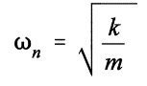 This solution is not not directly applicable to all the rotor system. Because rotor system are complex and we have to consider many things.

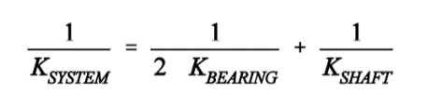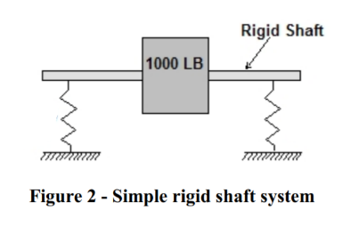For example if we consider a simple mass supported at bearings having stiffness(kb) and a shaft having stiifness (ks). The shaft is a spring supported on two other springs we call bearings. Springs in series add like resistors in parallel, that is inversely. So:

The stiffness of shaf can be found with the help of beam theory. It changes with the arrangement of the

Mass. In this case it can be written as

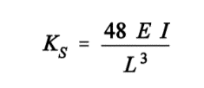 Shaft stiffness is the dominant factor in determining the critical speed of the shaft. If we change the shaft stiffness then it will change the critical speed of shaft.

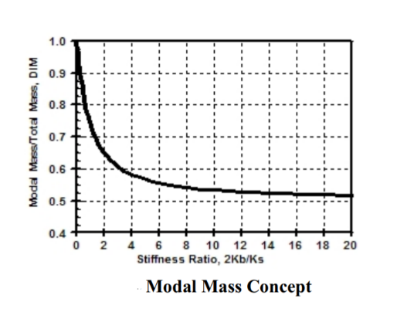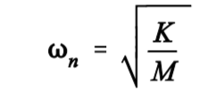There is one main concept of modal mass. Modal mass can be thought of as the effective mass "seen" by a particular mode at resonance. For a between bearing system at its first critical speed, the modal mass is equivalent to the mass that would yield an equivalent system if all the mass were lumped in the center of the span. Plot of modal mass (modal mass/total mass) as a function of the stiffness ratio between bearing and shaft stiffness (2Kb/Ks). The stiffness ratio is very important and greatly affects the modal mass ratio among other things. For very less support stiffness the modal mass becomes equal to the total mass of system. As the support stiffness becomes larger than shaft stiffness than it reaches asymptomatically to 0.5. For most practical cases it is between 0.5 to 0.6.

Now here k is system stiffness and M is the modal mass of the system. So, the modal mass is less than total mass so its first critical speed comes higher than if we take total mass of the system. This method works very well with the between bearing rotors with evenly distributed external masses.

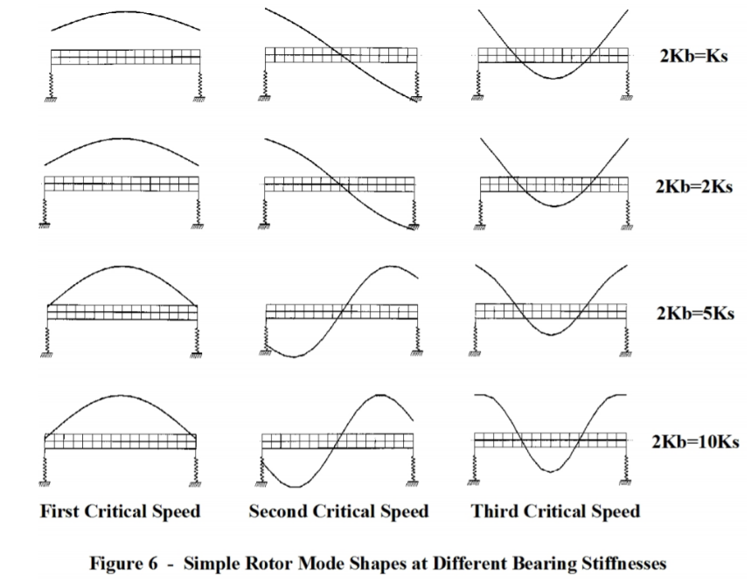**Mode shapes:** It is associated with the resonance occurring at critical speed. Mode shapes are defined at the resonance and independent of forcing function. The mode shapes of any resonance of any rotor are only dependent on the shaft stiffness, the bearing stiffness, the shaft mass and the mass and distribution of the components mounted on the shaft. The stiffness ratio is used to understand the behavior of mode shapes. Now the stiffness ratio is varied and its effects on mode shapes are seen.

In First critical speed when the bearing are soft than the shaft feels very less bending and as the stiffness ratio increases the shaft starts to bend more.

The second critical speed has a rocking or pivotal motion with a point of no motion in the center. This is called a node point. At low stiffness ratio there is no bending at all but at high stiffness ratio the shaft takes as shape.

In The third critical speed is different. At low (even zero) bearing stiffnesses, the rotor has a definite bent shape. This is a free-free or “bearing less” mode. The third critical speed mode shape has 2 node points regardless of the bearing stiffnesses

For design purposes the deflection in first critical speed has to be controlled so we take that into consideration.

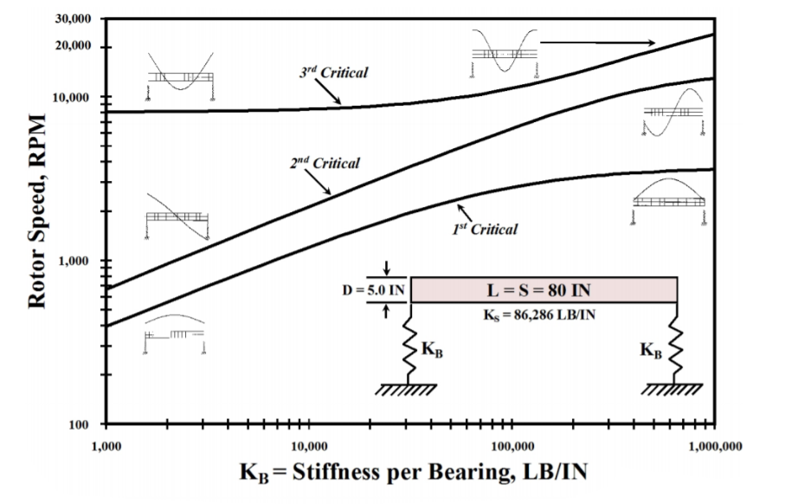**Critical speed map: -** One of the most useful tools available to anyone evaluating the rotor dynamics of a rotor bearing system is the undamped critical speed map. This device allows us to completely quantify the possible critical speeds of our machine. It gives a very good idea about what will happen if bearing and shaft parameters changed. In this we draw a log-log plot between the rotor speed and bearing stiffness. As we change the stiffness the critical speeds changes. The curve is for a shaft of 5inch diameter,80 inch length and stiffness 86286 LB/IN.

The first critical increases as we increase the stiffness of the bearing as the stiffness of a bearing reaches a certain point curve starts to become asymptotic. So now there is very change in critical speed with the bearing stiffness. So this zone in independent of bearing stiffness

The second critical speed behaves similarly while the third critical speed shows no significant variation for bearing stiffnesses up to certain level and then critical speed start increasing with bearing stiffness. The corresponding mode shapes for each resonance are indicated for low and high support stiffnesses.

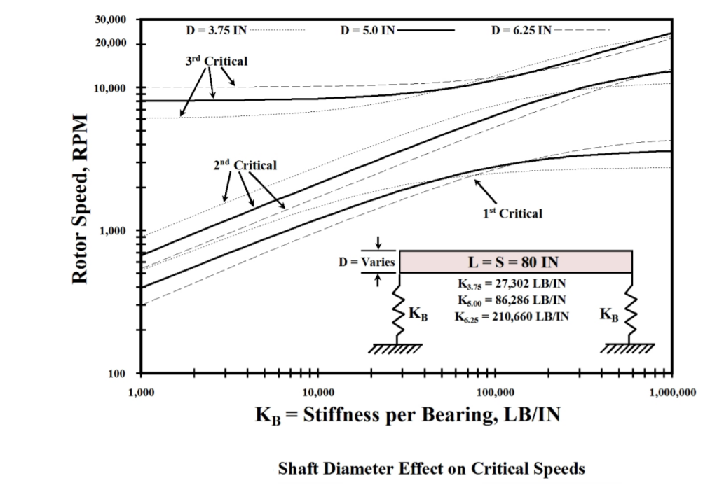**16.2.1) Effect of other various parameters: -**

**Effect of bearing span:** Take the previous shaft if we increase the bearing span the length of the shaft will decrease. Due to length stiffness of the shaft also increases which increases the first critical speed of the shaft. the mode is purely translational at very low support stiffnesses, the bearings exert less influence than at higher support stiffnesses when bending is introduced. The shorter span induces more bending at high support stiffnesses

In the second critical speed there is decrease in critical speed at low bearing stiffness. But after a certain point second critical speed increases with the bearing stiffness. At low stiffnesses this mode is pivotal with maximum amplitudes at the rotor ends and a node point in the center. Moving the bearings inward moves them away from the area of maximum amplitude and thus decreases their effectiveness. It is very important to note that the closer to a pivot point (node) the less effective a bearing will be. This is the reason for the decrease in the second critical speed for the shortened span case at low support stiffnesses

Third critical speed experience a similar phenomenon at low support stiffness. But as the stiffness increases it starts to decrease.

This method of reducing bearing span is used to increase the critical speed of the shaft.

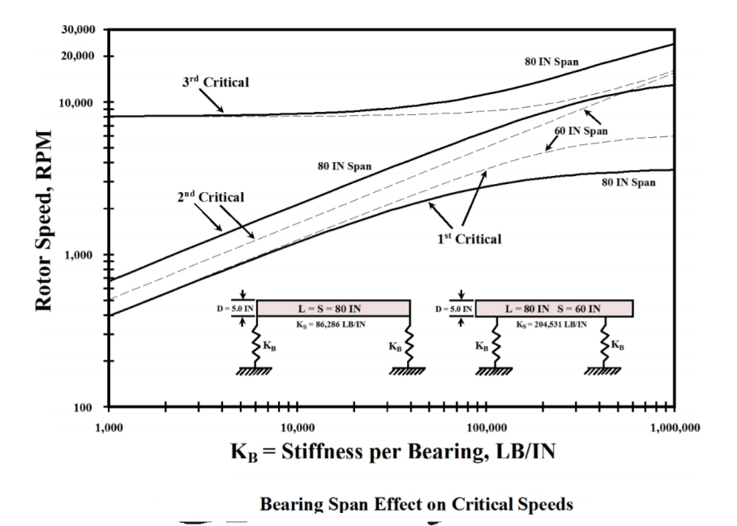**Effect of shaft diameter:** the shaft diameter is very important factor in designing the components like compressor and turbine. So if we decrease the diameter of shaft then mass of system reduces and inertia of shaft decrease due to which stiffness of shaft increases and system stiffness decrease so there is increase in critical speed at low stiffness. But as we reach to the high stiffness then this starts to flatten down and decreases. Because shaft is very flexible and bearing stiffness becomes dominant factor in this. In large diameter shaft it is opposite

The second critical speed curves show a response similar to the first critical and for the same reasons. The mass influence is even greater and the support stiffness must be greater than certain point before the larger shaft's second critical increases over the baseline case.

The third critical is a bit different in that at low support stiffnesses, the system is inherently a bending mode and the stiffer shaft will be more resistant with the larger diameter and have a higher third critical speed. Likewise, the smaller diameter shaft will be less resistant to bending.

The concept of shaft diameter increase is used in designing the turbine shaft diameter where we increase the shaft diameter to increase critical speed and reducing the amplification factor for resonance.

**Effect of mass distribution:** Since masses added to the shaft appear to have a significant effect, let’s look at some limiting cases. We take 3 cases of uniform distribution, single point mass distribution, lumped mass at quarter spans. In all cases the total rotor mass is identical as is the shaft diameter of 5 inches.

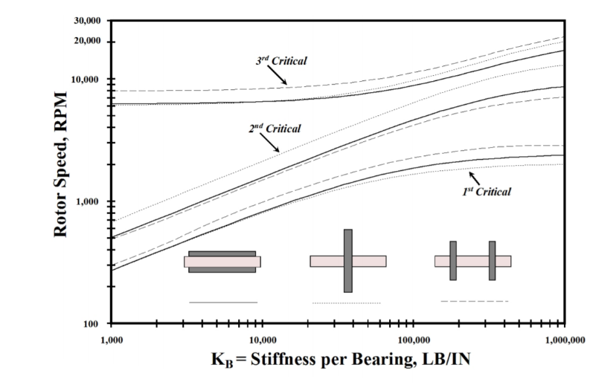The first critical speed is higher for quarter spanned and lowest for center lumped. This is because the modal mass in case of centre lumped is high so critical speed Is less. Modal mass of quarter span is more so less critical speed.

The mass distribution has an opposite effect on the second critical speed. This is because node point is at center so lumped mass has no effect no affect at it therefore the second critical speed is more. And quarter span has lowest second critical speed.

The third critical speed is again different. The uniform case has the lowest third critical speed and the quarter span case has the highest. The third critical speed is again different. The uniform case has the lowest third critical speed and the quarter span case has the highest.it is because the mode shapes at third critical speed is that in quarter span there are node close to masses therefore critical speed increases. In the center span case puts the mass at a point of maximum amplitude and is effective in lowering the third critical speed. In uniform case it is the lowest.

So, for understanding if mass is put at node then modal mass decreases critical speed increases. If mass Is placed at maximum amplitude point then modal mass increases thus lowering the critical speed.

**Unbalance response system**: the most common excitation that is observed in a system in due to presence of imbalance in system. The imbalance may be because of many elements like due to erosion and wear of rotor, buildup of material at rotor. So, it is very necessary to identify that where the imbalance is present. How much imbalance can be accommodated in a system before it will fail. Therefore, damping is introduced in system because it is the only thing which controls the amplification at resonance. The generally accepted balance tolerance in wide use today is 4W/N or 4 times the rotor weight in pounds divided by the maximum continuous speed in RPM.

To begin an analysis, mode shapes for a rotor are produced using the actual predicted bearing stiffnesses. In the case of shaft at its first mode shape whole imbalance is at center. In second mode imbalance is divided in two ends. And similarly, imbalance divides in higher mode shapes. So, to d the analysis of unbalance we must have information about mode shapes. Once the results of an unbalance response are obtained, the user can calculate an amplification factor as outlined earlier and begin to get a feel for the rotor's sensitivity.

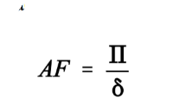**Stability Analysis:** Stability analysis is the most difficult aspect of rotor dynamics. It is not nearly as well understood as the previously covered subjects and the computer programs that are available require that the user estimate the amount of destabilizing influences in the system. The destabilizing forces are commonly designated cross-coupling forces. These cross coupling forces cause an orthogonal forward displacement of the rotor for each normal rotor displacement. If the force is sufficient in magnitude to overcome the damping in the system, an instability occurs. Stability is a function of rotor geometry, bearing-to-shaft stiffness ratio, bearings, seals, and fluid dynamics. The best measure of rotor stability is the logarithmic decrement. Often called the log dec for short, this factor is related to amplification factor and is defined as the natural log of the ratio of two successive resonant amplitudes. When the log dec is positive, the systems vibrations die out with time and the system is stable. However, if the log dec is less than zero, the system's vibrations grow with time and the system is unstable. The relationship of the log dec, abbreviated “*” to amplification factor is this:

The log dec can be experimentally determined by momentarily exciting a running rotor at one of its natural frequencies either by a forcing function or an impulse. By recording the resultant "ring-down" the log dec can be calculated.

Now when all things are known about the rotor the response of casing can be calculated using theoretical approach. So we come to know about the excitation in casing then we have to do modal analysis of casing to see if these excitation are causing resonances or not. Modal analysis is done by FEM.

**17) Theory of fem: -**Many physical phenomena in engineering and science can be described in terms of partial differential equations. Solving the partial differential equations by using the analytical methods is very difficult. Because it requires high solving capacities. The finite element method is a numerical approach by which partial differential equations are solved. The FEM is a method for solving engineering problems such as stress analysis, heat transfer, fluid flow and electromagnetics by computer simulation.

**17.1) General Description of The Finite Element Method: -** In the finite element method, the actual continuum or body of matter, such as a solid, liquid, or gas, is represented as an assemblage of subdivisions called finite elements. These elements are considered to be interconnected at specified joints called nodes or nodal points.

• The nodes lie on the element boundaries where adjacent elements are connected.

• The actual variation of the field variables (e.g., displacement, stress, temperature, pressure, or velocity) inside the element is not known, it is assumed that the variation of the field variable inside a finite element can be approximated by a simple function.

• These approximating functions (also called interpolation models) are defined in terms of the values of the field variables at the nodes.

• When field equations (like equilibrium equations) for the whole continuum are written, the new unknowns will be the nodal values of the field variable.

• By solving the field equations, which are generally in the form of matrix equations, the nodal values of the field variable will be known.

• Once these are known, the approximating functions define the field variable throughout the assemblage of elements.

• The solution of a general continuum problem by the finite element method always follows an orderly step-by-step process.

**17.2)** With reference to **static structural problems**, the step-by-step procedure can be stated as follows:

**Step (i): Discretization of the structure**

In this first the structure is divided into the finite no. of elements. So, to do that we have to decide what type of elements are to used for division. We have to decide the properties of elements like number of elements, size of elements and arrangement of elements has to be decided. This is done with the help of meshing.

**Step (ii): Selection of a proper interpolation model for displacement**

It is very complex to find an exact interpolation model of the effect. So, we assume a interpolation model of a complex structure within elements in such a way that it form a simple equation for computer standpoint. But it must satisfy the convergence relations.

Generally, the assumed solution is polynomial. Linear, quadratic and cubic polynomial are generally used to define the function. Sometimes trigonometric functions are also used to get better results

**Step (iii): Derivation of element stiffness matrices**

The third includes calculations of stiffness matrices for the elements we have created according to the displacement model. The mass matrix, load matrices on the structure to calculated with the help of governing equations and boundary conditions.

**Step (iv): Assemblage of element equations to obtain the overall equilibrium equations**

The structure of is very complex in this step elements equation are written and get combined in specific manner in such a way that combined equation can be calculated. This combined equation is called governing equation.

For static structural analysis it is

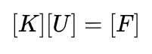 Where [k] is stiffness matrix of elements, [u] is vector of nodal displacements, [f] is nodal load load matrix

For modal analysis the governing equation is given below

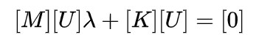here [m] is nodal mass matrices and [k] is stiffness matrix for elements

**Step (v): Solution for the unknown nodal displacements**

For nodal displacements entire equation is modified in such a way that we can include boundary conditions to get the results. For linear analysis this step is easy but for the non linear analysis solution is obtained by a no. of steps

For modal analysis eigen values have to be calculated from the governing equation. These eigen values are equal to the square of natural frequency of the system. To get mode shapes these eigen values are put into the governing equations. And we get the mode shapes and natural frequencies which is used for vibration analysis.

**Step (vi): Computation of element strains and stresses: -**

From the known nodal displacements and mode shapes

if required, the element strains and stresses can be computed by using the necessary equations of solid or structural mechanics.

The terminology used in the previous six steps has to be modified if we want to extend the concept to other fields. For example, we have to use the term continuum or domain in place of structure, field variable in place of displacement, characteristic matrix in place of stiffness matrix, and element resultants in place of element strains.

**Step (vii) : Interpret the Results**:

now the results are interpreted in the form visuals of deformed material shapes, red zone where stresses and deformations are maximum. So that we can see it for design purpose that material will not fail.

**18) Meshing :-** meshing is just discretization of continuous body. It means we are dividing the whole body to small no. of elements. By doing we are reducing the no. of degrees of freedom of the system from infinite to a finite no. so that there are limited number of equations that has to be solved.

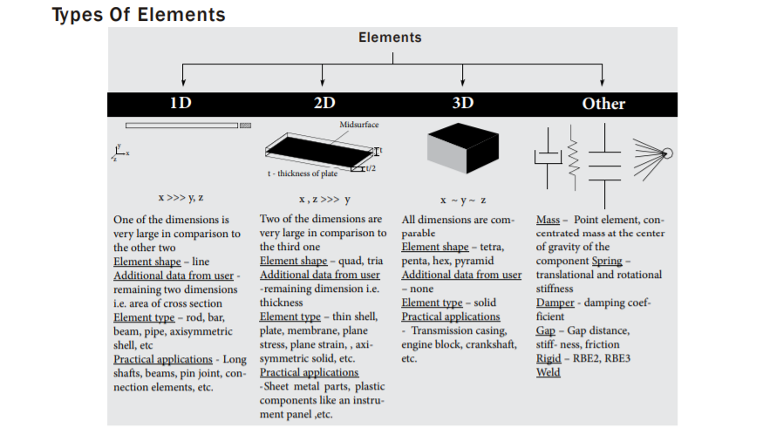**18.1) Types of elements :** there are mainly three type of elements 1d elements, 2d elements, 3d elements.

**18.2) Selection of elements:**  selection of elements is done on bases of two parameters

1. **Geometric shape of the model** :-

If the geometric shape of model such that one dimension is very large compared to the other two lengths then we use 1d elements like for rods, bar,beam , pipes. 1d elements shape is line.

If the geometric shape of the model is in the form of a shell or plate means one dimension is negligible compared to others then we use 2d element like for thin shell, membrane we use 2d meshing. 2d shapes are quad and tria

If the shape is such that all dimensions are comparable then we use 3d elements like for shapes like crank, connecting rod etc. 3d element shape are tetra, Penta, hex and pyramid.

1. **Type of analysis**: analysis type is very important to decide the element shape

**For static and fatigue analysis**: in this analysis hex, quad are preferred over tria, penta and tetra

**For crash and non linear analysis**: it is preferred to maintain flow lines here brick elements are preferred over tetrahedron.

**For mold flow analysis:** triangular elements are preferred.

**For modal analysis:** quad and hex elements are used. It is because tria elements are stiffer

So if we use them the natural frequency will come wrong.

**18.3) Element size**: it is decided on the basis of computing ability of hardware, time taken for a particular analysis to be done. For example, static analysis takes less time so we can use less element size, but vibration analysis takes longer time so we have to larger element size so that no. of nodes are less. In critical area we have to use small element size. Because in that region we require large no. of nodes to get accurate result.

**18.4) Requirement before meshing**: before meshing we have to check geometry for

* Scar lines
* Duplicate surfaces
* Free edges
* Small fillets
* Small holes
* Defect Intersection of surfaces

If any of these defects are present in geometry than we have remove these to get correct mesh in less time.

Meshing in critical regions: Critical regions are those regions where stresses produced are very high. here we don’t use triangular elements. We use hex and quad elements for meshing in critical region.

**18.5) Element shapes**

1d element shape is line

2d element shape is quad and tria. these are further divided into linear and parabolic. These both linear and parabolic are of different properties we use linear the most. trias are not used because they are stiffer than quad so we don’t use them

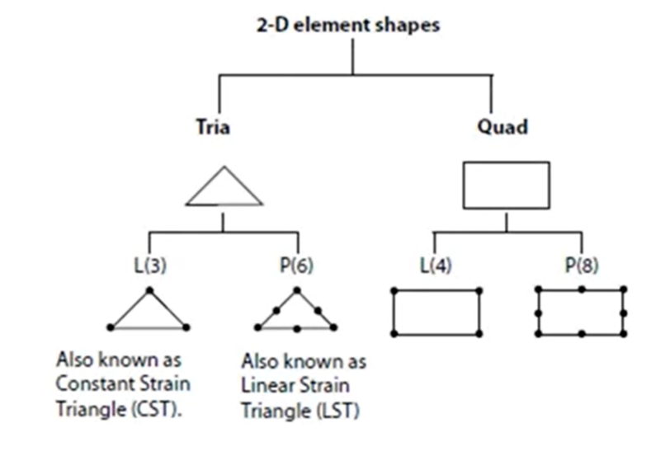

3d elements also have linear and parabolic elements. We mostly use linear hex or brick mesh because it gives the best results and easy to be done. All solid elements have only 3 dof of freedom. They have only translational degree of freedom. Because it is very difficult to bend and twist the element. But 2d elements have 6 dof. Because they can be bended and twisted

**18.6) Quality checks**

**Quality checks for 2d meshing:** there are many quality checks that are present for quality of mesh and elements.

Few main quality aspects are

1. 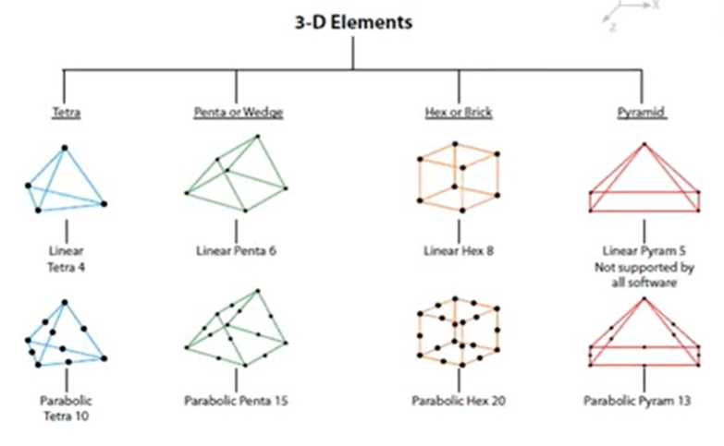Aspect ratio: it is maximum to minimum edge length its ideal value is 1 but acceptable value is less than 5.
2. Skew: for quad elements it is the 90- the minimum angle between two lines joining the mid points of opposite sides. Acceptable value is less than 45o.
3. Jacobian: it is the most important property of all. It is the scale factor arising because of transformation. Because elements are transformed from global to local coordinates for faster analysis. Ideal value is 1 but acceptable value is more than 0.6

**Quality checks for brick elements**: ideal shape of brick element is cube. But due geometric shape it can vary.

1. Warp angle: it is calculated on the quadrilateral (hex) of an solid element. It is angle between planes that form by splitting the quad elements. Ideal value is 0. But acceptable is less than 30o.
2. Aspect ratio: maximum by minimum edge ratio. Ideal is 1. But acceptable value is less than
3. Jacobian : it is the scale factor arising from the transformation from global to local system.

Ideal value is 1 but acceptable under 0.5

There are many ways in all the software’s to make the quality of mesh good.

**19) Modal analysis of aero engine casing:**  To do the modal analysis of casing there are three steps involved

**19.1) Preprocessing of model:** - preprocessing is done by the user so that analysis can be done. in our project preprocessing is done in the hypermesh. It is commercial FEA software in which we can both preprocessing and post processing. But in this project only modelling and meshing is done in hypermesh. Material, boundary conditions and analysis is done in ANSYS Apdl

1. Modelling of structure
2. Type of analysis
3. Meshing of structure
4. Material properties
5. Boundary conditions

It involves mainly of following steps

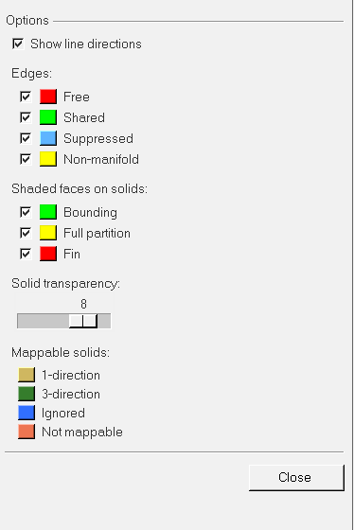**19.1.1) Geometry formation:** Casing is of the circular form so cut the casing with the help of a plane (a plane along the axis of casing passing through center of circle) then a cross section is formed. We started by making center of the casing at (0,0) and modelling that cross-section by maintaining the appropriate distance (according to the given geometry) from the center of casing. Using the Surface Ruled option (under Surface tab) and selecting the 2D cross-section lines, 2D surface of the cross-section is formed. After that using ‘spin’ option (under solid tab), the surface is full spin about the appropriate axis passing through the center of the casing, resulting in the formation of 3D solid model of the casing. Now, the casing also has holes, so to create holes firstly a solid cylinder of same radius as that of holes is created (under solid tab) at the location where holes needs to be created and then using ‘A-B Boolean’ option (under solid edit tab) where ‘A’ is the casing and ‘B’ is the cylinder, a hole is created at that location. And the remaining holes are created using ‘Rotate’ option by duplicating that hole. Finally, Modelling of required casing is completed.

Edge check and geometry clean up the first step should be check of unclosed edges and volumes along with any errors in the geometry. The icon ‘visualization option’ is selected from the Commands panel toolbars that opens the visualization page. This page contains several colors showing edges. If there are no free edges and all are shared edges the task here is done. Some shapes may not be defined well at a required level they have to be readdressed by Hyper Mesh. Auto cleanup option in the geometry page is enough to complete cleanup of all surfaces. All the surfaces are selected and auto cleaned with given parameters. Any more changes are done through the options available such as Quick edit, Edge edit, Point edit, Solid edit, Surface edit, Defeature etc.

**Fig visualization panel**

**19.1.2) Meshing of model**: Meshing is done in hypermesh. Because the analysis we are is modal analysis. **hex and quad elements** are used. Because model is 3d. casing contains holes so direct meshing of full casing is not a good option as the meshing of solid containing holes needs to be done separately. So, the casing is split in two parts such that one part contains holes and other contains the left part of the casing. This split can be done with the help of ‘solid edit’ option.

So, we will start with the meshing of the surface of cylinder containing holes. Now, before meshing, a surface is to be extracted from upper solid. Now we do the meshing of the surface in 2d meshing, with the help of ‘automesh’ option. Now to mesh the surface we have to split the surface. split of surface is done with the help of ‘quick edit’ option. such that each splitted surface contains one hole and then meshing of each part is done separately. In each part there is hole so

we mesh that region with very care. Mesh is done in such a way that mesh flow lines are maintained. In meshing, element size is set to ‘2’ and mesh type is set to ‘quad only’ and also

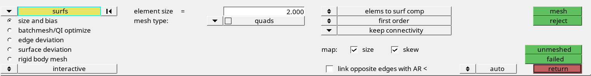

**Fig. automesh panel**

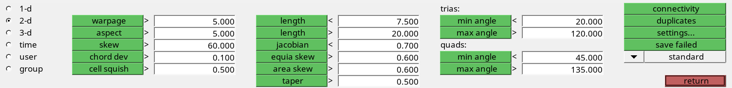 **Fig. quality checks for 2d**

‘keep connectivity’ is active. Now all parts of the mesh are connected to each other. Now we have to check for mesh quality on each divided surface with the help of ‘quality index’ option.

Here we have to check for Jacobian, aspect ratio, skew and other option shown in panel. If any of the criteria are not passing then we have to repair the elements that are failing. This can be repaired with help of ‘quality index’ option. here we can do many operations such move nodes, split elements to correct the mesh. Now the meshing is complete. Now it has to be converted to 3d mesh. Now the meshing of the surface containing holes is done and to mesh the solid containing this surface is done with the help of ‘drag element’ option (under 3D tab). Now the meshing of one part of surface is done. Check for quality of mesh in ‘check elements’(under tools tab)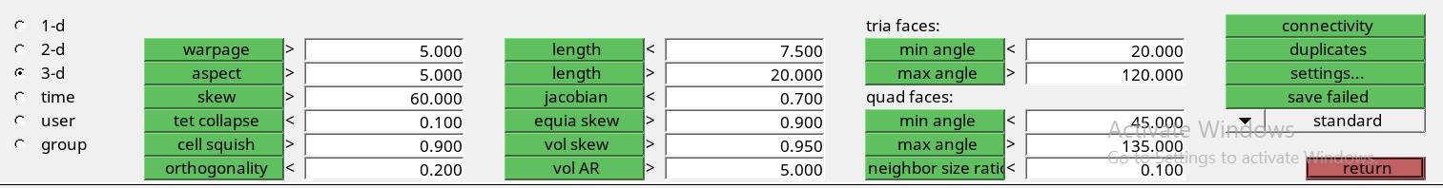

**Fig. quality checks for 3d**

The quality of elements is checked. If any problem comes it can be repaired

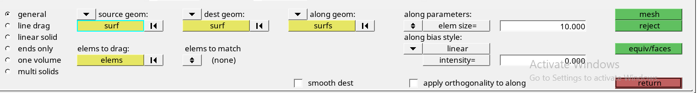Now To meshing the other part of the casing, we will use the cross-section (made while modeling) of that part and mesh that area using the ‘auto mesh’ option (under 2D tab) in which the element size is set to ‘2’ and mesh type is set to ‘quad only’ and also ‘keep connectivity’ is active. Using the ‘solid map’ option (under 3D tab), the remaining solid part is meshed by maintaining the mesh connectivity with the meshing of first part.

**Fig. solid map panel**

Now the quality of whole solid is checked and the error is coming under 2%. So this meshing is accepted. In whole procedure it is taken care that no. of nodes formed are not very high. Because in model analysis time required to do analysis is high. Now the meshing is complete.

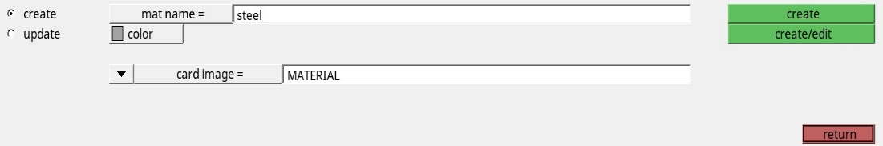**19.1.3) Material properties** now material properties are assigned to model this is done with the help of material tab. we give the card image as ‘material’. We will further define material in ansys.

**Fig. material properties panel**

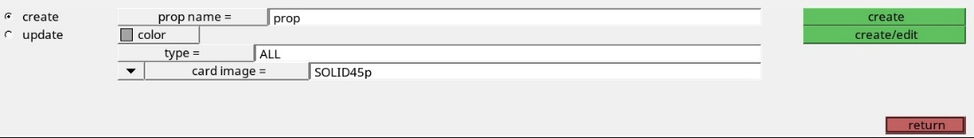  **Property assignment:**  now the property is assigned to the model. We give the card image of a property as ‘solid45p’ .it is a specific property type for analysis.

Now we have to create the element type so that this property can be given to that. To do that

**Fig. property panel**

we create new element type with the ‘ET type’ option (under utility tab

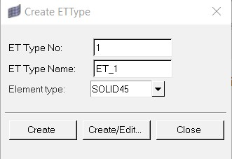 **fig. element type panel**

Now this element property is assigned to all the components

Now the work in hypermesh is completed. Means meshing and modelling is completed. Now the boundary conditions are to be applied in ANSYS APDL software. IT is a programing language which provides a versatile environment to do the analysis. so the model of the casing is exported into the ANSYS software where its analysis to be done.

**19.1.4) Boundary conditions and material properties (in ANSYS APDL):**  After exporting the file into the ANSYS APDL we have to set the preferences to structural. now the software is programmed for doing structural analysis like static analysis, modal analysis etc.

Now we have to assign the material properties for the linear analysis in material properties are assigned. E= 70 gpa , young’s modulus= 0.3, density=7800 kg/m3

Now the boundary conditions are applied with the help of loads option. In this we constraint the all 6 dof of casing.

**19.1.5) Type of analysis:**  in this project modal analysis is done for linear vibration system. In linear system the force is in linear relationship between the position of the mass. In this we are going to find the natural frequencies of structure. The number modes to be taken are 6. For this we are going to use hex and quad elements. Because they give very accurate results. Analysis is to be done ANSYS APDL. It is done under the solution option. where we have to define analysis as modal analysis

**19.2) Processing: -** In the processing the ANSYS APDL software uses the theory of FEM and solves for the eigen values and eigen vectors. eigen values are square of natural frequencies. And eigen vectors are mode shapes.

**19.3) Post processing: -** Results of the analysis can be seen with the ‘read results’ and contour plots. Here we get the eigen values and eigen vectors. We can also get deformed shapes of the structure to seen visually.

**References:**

1. Gas turbine theory by HIH Saravanamuttoo Gordon Frederick Crichton Rogers, Henry Cohen
2. Gas turbines by V. Ganesham
3. Strength of material by S.S Rattan
4. Mechanical vibration by S.S Rao
5. Practical Aspects of Finite Element Simulation by Altair university
6. Structural Dynamics and Vibration in Practice by Douglas thorby
7. A Practical Guide to Rotor Dynamics MALCOLM E. LEADER, P.E. Applied Machinery Dynamics Company